**Mini Project: COVID19 Help**

**Developed by:** Neha Sadanand Patil

**Roll No:** 186140

**Introduction:**

World is facing Coronavirus pandemic caused by Coronavirus. The disease is called as COVID19 disease.

Thousands of people are getting infected by the deadly virus each day. Thousands of people are losing their battel with COVID19.

As the healthcare system of India is overburdened and hospitals are flooding with COVID19 patients, people are stressed out with resources.

They are finding it difficult to get proper data about bed availability, choosing their vaccine centers and finding test centers near their place.

There is strong need of data which will help people finding beds, vaccine centers, testing centers, emergency numbers for urgency and of course the positivity of COVID19 cases.

This project particularly aims at Nandurbar district of Maharashtra.

We intend to help people whilst the COVID19 battle.

This projects will help people searching bed availability. They can get information about test centers near them. They will be able to fathom vaccine centers for themselves. Can get helpline numbers during emergency. They will be able to acknowledge COVID19 cases in their district.

With this project we hope to help people fighting COVID19 battle.

**Software Used:**

1. Visual Studio 2019 Community Version
2. Chrome browser
3. IIS Server

**Languages and Frameworks used:**

1. HTML
2. CSS
3. BOOTSTRAP
4. ASP.NET ( C# )
5. MYSQL

**Program:**

**index.html**

<!DOCTYPE html>

<html>

<head>

<meta charset="utf-8" />

<!-- bootstrap cdn -->

<link rel="stylesheet" href="https://stackpath.bootstrapcdn.com/bootstrap/4.5.2/css/bootstrap.min.css" integrity="sha384-JcKb8q3iqJ61gNV9KGb8thSsNjpSL0n8PARn9HuZOnIxN0hoP+VmmDGMN5t9UJ0Z" crossorigin="anonymous">

<!-- font awesome link -->

<link rel="stylesheet" href="https://use.fontawesome.com/releases/v5.14.0/css/all.css" integrity="sha384-HzLeBuhoNPvSl5KYnjx0BT+WB0QEEqLprO+NBkkk5gbc67FTaL7XIGa2w1L0Xbgc" crossorigin="anonymous">

<link rel="preconnect" href="https://fonts.gstatic.com">

<link href="https://fonts.googleapis.com/css2?family=Montserrat:wght@300;400;500;700&display=swap" rel="stylesheet">

<link href="css/style.css" rel="stylesheet" />

<title>COVID19 HELP</title>

</head>

<body>

<section id="header">

<div class="container-fluid">

<nav class="navbar navbar-expand-lg navbar-dark ">

<div class="container">

<a class="navbar-brand" href="#">COVID19 HELP</a>

<button class="navbar-toggler" type="button" data-bs-toggle="collapse" data-bs-target="#navbarSupportedContent" aria-controls="navbarSupportedContent" aria-expanded="false" aria-label="Toggle navigation">

<span class="navbar-toggler-icon"></span>

</button>

<div class="collapse navbar-collapse" id="navbarSupportedContent">

<ul class="navbar-nav ml-auto ">

<li class="nav-item">

<a class="nav-link active" aria-current="page" href="#service">Get Help</a>

</li>

<li class="nav-item">

<a class="nav-link active" href="admin/login.aspx">Admin</a>

</li>

</ul>

</div>

</div>

</nav>

</div>

</section>

<section class="main">

<div class="container">

<div class="d-flex justify-content-center align-items-center">

<h2>COVID19 HELP NANDURBAR</h2>

</div>

</div>

</section>

<section id="service">

<div class="container">

<h1 class="text-center mt-5">GET HELP</h1>

<hr style="width: 200px; margin: auto; border: 1px solid #547eb6;"/>

<div class="services">

<div class="shape rounded-pill">

<a href="displayBedAvail.aspx">Bed Availability</a>

</div>

<div class="shape rounded-pill">

<a href="displayVaccineCenter.aspx">Vaccination Centers</a>

</div>

<div class="shape rounded-pill">

<a href="displayEmergencyPhone.html">Emergency Numbers</a>

</div>

<div class="shape rounded-pill">

<a href="displayTestCenter.aspx">Test Centers</a>

</div>

<div class="shape rounded-pill ">

<a href="displayCovidInfo.aspx">COVID Dashboard</a>

</div>

</div>

</div>

</section>

<section class="content">

<h1 class="text-center mt-5">REMEMBER THIS</h1>

<hr style="width: 340px; margin: auto; border: 1px solid #547eb6;" />

<div class="container">

<div class="d-flex justify-content-around">

<div>

<img src="images/01.png" alt="Alternate Text" style="width: 250px;" />

</div>

<div>

<img src="images/02.png" alt="Alternate Text" style="width: 250px;" />

</div>

<div>

<img src="images/03.png" alt="Alternate Text" style="width: 250px;" />

</div>

</div>

<div class="d-flex justify-content-around">

<div>

<img src="images/04.png" alt="Alternate Text" style="width: 250px;" />

</div>

<div>

<img src="images/05.png" alt="Alternate Text" style="width: 250px;" />

</div>

<div>

<img src="images/06.png" alt="Alternate Text" style="width: 250px;" />

</div>

</div>

</div>

</section>

<br />

<section class="footer mt-5">

<div style="background-color: #ebf5fc ;padding: 40px; text-align: center; margin-top: 50px;">

<h6>Developed by Neha Patil.</h6>

</div>

</section>

<!-- js cdn -->

<script src="https://code.jquery.com/jquery-3.5.1.slim.min.js" integrity="sha384-DfXdz2htPH0lsSSs5nCTpuj/zy4C+OGpamoFVy38MVBnE+IbbVYUew+OrCXaRkfj" crossorigin="anonymous"></script>

<script src="https://cdn.jsdelivr.net/npm/popper.js@1.16.1/dist/umd/popper.min.js" integrity="sha384-9/reFTGAW83EW2RDu2S0VKaIzap3H66lZH81PoYlFhbGU+6BZp6G7niu735Sk7lN" crossorigin="anonymous"></script>

<script src="https://stackpath.bootstrapcdn.com/bootstrap/4.5.2/js/bootstrap.min.js" integrity="sha384-B4gt1jrGC7Jh4AgTPSdUtOBvfO8shuf57BaghqFfPlYxofvL8/KUEfYiJOMMV+rV" crossorigin="anonymous"></script>

</body>

</html>

**Web.config**

<?xml version="1.0" encoding="utf-8"?>

<!--

For more information on how to configure your ASP.NET application, please visit

https://go.microsoft.com/fwlink/?LinkId=169433

-->

<configuration>

<connectionStrings>

<add name="CovidHelp" connectionString="Data Source=(LocalDB)\MSSQLLocalDB;AttachDbFilename=|DataDirectory|\bedAvailability.mdf;Integrated Security=True"

providerName="System.Data.SqlClient" />

<add name="ConnectionString" connectionString="Data Source=(LocalDB)\MSSQLLocalDB;AttachDbFilename=|DataDirectory|\vaccination.mdf;Integrated Security=True"

providerName="System.Data.SqlClient" />

<add name="testCenter" connectionString="Data Source=(LocalDB)\MSSQLLocalDB;AttachDbFilename=|DataDirectory|\testCenters.mdf;Integrated Security=True"

providerName="System.Data.SqlClient" />

<add name="ConStr" connectionString="Data Source=(LocalDB)\MSSQLLocalDB;AttachDbFilename=|DataDirectory|\admintbl.mdf;Integrated Security=True"

providerName="System.Data.SqlClient" />

<add name="covidData" connectionString="Data Source=(LocalDB)\MSSQLLocalDB;AttachDbFilename=|DataDirectory|\covidData.mdf;Integrated Security=True"

providerName="System.Data.SqlClient" />

</connectionStrings>

<system.web>

<compilation debug="true" targetFramework="4.7.2" />

<httpRuntime targetFramework="4.7.2" />

</system.web>

<system.codedom>

<compilers>

<compiler language="c#;cs;csharp" extension=".cs" type="Microsoft.CodeDom.Providers.DotNetCompilerPlatform.CSharpCodeProvider, Microsoft.CodeDom.Providers.DotNetCompilerPlatform, Version=2.0.1.0, Culture=neutral, PublicKeyToken=31bf3856ad364e35" warningLevel="4" compilerOptions="/langversion:default /nowarn:1659;1699;1701" />

<compiler language="vb;vbs;visualbasic;vbscript" extension=".vb" type="Microsoft.CodeDom.Providers.DotNetCompilerPlatform.VBCodeProvider, Microsoft.CodeDom.Providers.DotNetCompilerPlatform, Version=2.0.1.0, Culture=neutral, PublicKeyToken=31bf3856ad364e35" warningLevel="4" compilerOptions="/langversion:default /nowarn:41008 /define:_MYTYPE=\&quot;Web\&quot; /optionInfer+" />

</compilers>

</system.codedom>

</configuration>

**displayBedAvail.apsx**

<%@ Page Language="C#" AutoEventWireup="true" CodeBehind="displayBedAvail.aspx.cs" Inherits="COVID19Help.displayBedAvail" %>

<!DOCTYPE html>

<html xmlns="http://www.w3.org/1999/xhtml">

<head runat="server">

<meta charset="utf-8" />

<link href="../Content/bootstrap.min.css" rel="stylesheet" />

<script src="../Scripts/bootstrap.min.js"></script>

<link rel="preconnect" href="https://fonts.gstatic.com" />

<link href="https://fonts.googleapis.com/css2?family=Montserrat:wght@300;400;500;700&display=swap" rel="stylesheet" />

<link href="css/style.css" rel="stylesheet" />

<title>COVID19 HELP</title>

</head>

<body>

<section>

<div class="container-fluid bed-design d-flex justify-content-around align-items-center">

<h1>COVID19 HELP</h1>

<a href="index.html">HOME</a>

</div>

</section>

<form id="form1" runat="server">

<div class="container">

<h1 class="display-4 text-center mt-3" style="font-weight:400;">Bed Availability</h1>

<div class="row">

<div class="col-lg-12">

<div class="table-responsive">

<asp:SqlDataSource ID="SqlDataSource1" runat="server" ConnectionString="<%$ ConnectionStrings:CovidHelp %>" SelectCommand="SELECT * FROM [bedAvailability]"></asp:SqlDataSource>

<br />

<asp:GridView ID="GridView1" runat="server" AutoGenerateColumns="False" DataSourceID="SqlDataSource1" Width="100%" CssClass="table table-striped table-bordered table-hover">

<Columns>

<asp:TemplateField headertext="Hospital">

<ItemTemplate>

<br />

<p>

<a data-bs-toggle="collapse" href="#collapseExample" role="button" aria-expanded="false" aria-controls="collapseExample">

<%# Eval ("hospital_name") %>

</a>

</p>

<div class="collapse" id="collapseExample">

<div class="card card-body">

<p>Address: <%# Eval ("address") %></p>

<p>Contact Person: <%# Eval ("contact_person") %></p>

<p>Phone: <%# Eval ("phone") %></p>

</div>

</div>

</ItemTemplate>

</asp:TemplateField>

<asp:BoundField DataField="tehsil" HeaderText="Tehsil" SortExpression="tehsil" HeaderStyle-CssClass="visible-lg" ItemStyle-CssClass="visible-lg"/>

<asp:BoundField DataField="ICU_bed_total" HeaderText="ICU Bed Total" SortExpression="ICU_bed_total" HeaderStyle-CssClass="visible-lg" ItemStyle-CssClass="visible-lg"/>

<asp:BoundField DataField="ICU_bed_occupied" HeaderText="ICU Bed Occupied" SortExpression="ICU_bed_occupied" HeaderStyle-CssClass="visible-lg" ItemStyle-CssClass="visible-lg"/>

<asp:BoundField DataField="ICU_bed_avail" HeaderText="ICU Bed Avail" SortExpression="ICU_bed_avail" HeaderStyle-CssClass="visible-lg" ItemStyle-CssClass="visible-lg"/>

<asp:BoundField DataField="oxygen_bed_total" HeaderText="Oxygen Bed Total" SortExpression="oxygen_bed_total" HeaderStyle-CssClass="visible-lg" ItemStyle-CssClass="visible-lg"/>

<asp:BoundField DataField="oxygen_bed_occupied" HeaderText="Oxygen Bed Occupied" SortExpression="oxygen_bed_occupied" HeaderStyle-CssClass="visible-lg" ItemStyle-CssClass="visible-lg"/>

<asp:BoundField DataField="oxygen_bed_avail" HeaderText="Oxygen Bed Avail" SortExpression="oxygen_bed_avail" HeaderStyle-CssClass="visible-lg" ItemStyle-CssClass="visible-lg"/>

<asp:BoundField DataField="isolation_bed_total" HeaderText="Isolation Bed Total" SortExpression="isolation_bed_total" HeaderStyle-CssClass="visible-lg" ItemStyle-CssClass="visible-lg"/>

<asp:BoundField DataField="isolation_bed_occupied" HeaderText="Isolation Bed Occupied" SortExpression="isolation_bed_occupied" HeaderStyle-CssClass="visible-lg" ItemStyle-CssClass="visible-lg"/>

<asp:BoundField DataField="isolation_bed_avail" HeaderText="Isolation Bed Avail" SortExpression="isolation_bed_avail" HeaderStyle-CssClass="visible-lg" ItemStyle-CssClass="visible-lg"/>

</Columns>

</asp:GridView>

</div>

</div>

</div>

</div>

</form>

</body>

</html>

**displayCovidInfo.aspx**

<%@ Page Language="C#" AutoEventWireup="true" CodeBehind="displayCovidInfo.aspx.cs" Inherits="COVID19Help.displayCovidInfo" %>

<!DOCTYPE html>

<html xmlns="http://www.w3.org/1999/xhtml">

<head runat="server">

<meta charset="utf-8" />

<link href="../Content/bootstrap.min.css" rel="stylesheet" />

<script src="../Scripts/bootstrap.min.js"></script>

<link rel="preconnect" href="https://fonts.gstatic.com" />

<link href="https://fonts.googleapis.com/css2?family=Montserrat:wght@300;400;500;700&display=swap" rel="stylesheet" />

<link href="css/style.css" rel="stylesheet" />

<title>COVID19 HELP</title>

</head>

<body>

<div class="container-fluid">

<section>

<div class="container-fluid bed-design d-flex justify-content-around align-items-center">

<h1>COVID19 HELP</h1>

<a href="index.html">HOME</a>

</div>

</section>

<div class="container">

<h1 class="text-center mt-5">COVID19 DASHBOARD</h1>

<div class="services">

<form id="form2" runat="server">

<asp:SqlDataSource ID="SqlDataSource1" runat="server" ConnectionString="<%$ ConnectionStrings:covidData %>" SelectCommand="SELECT * FROM [covidinfo]"></asp:SqlDataSource>

<br />

<asp:GridView ID="GridViewCovid" runat="server" AutoGenerateColumns="False" DataSourceID="SqlDataSource1" Width="50%"

ShowFooter="True" DataKeyNames="Id" OnSelectedIndexChanged="GridViewCovid_SelectedIndexChanged">

<Columns>

<asp:TemplateField HeaderText="" HeaderStyle-CssClass="visible-lg" ItemStyle-CssClass="visible-lg">

<ItemTemplate >

<div class="shape-two rounded-pill">

<p class="mt-5">Total Swab</p>

<b class="text-primary"><asp:Label Text='<%# Eval("totalSwab") %>' runat="server" /></b>

</div>

</ItemTemplate>

</asp:TemplateField>

<asp:TemplateField HeaderText="" HeaderStyle-CssClass="visible-lg" ItemStyle-CssClass="visible-lg">

<ItemTemplate>

<div class="shape-two rounded-pill">

<p class="mt-5">Total Positive</p>

<b class="text-danger"><asp:Label Text='<%# Eval("totalPositive") %>' runat="server" /></b>

</div>

</ItemTemplate>

</asp:TemplateField>

<asp:TemplateField HeaderText="" HeaderStyle-CssClass="visible-lg" ItemStyle-CssClass="visible-lg">

<ItemTemplate>

<div class="shape-two rounded-pill">

<p class="mt-5">Total Active</p>

<b class="text-danger"><asp:Label Text='<%# Eval("totalActive") %>' runat="server" /></b>

</div>

</ItemTemplate>

</asp:TemplateField>

<asp:TemplateField HeaderText="" HeaderStyle-CssClass="visible-lg" ItemStyle-CssClass="visible-lg">

<ItemTemplate>

<div class="shape-two rounded-pill">

<p class="mt-5">Total Death</p>

<b class="text-danger"><asp:Label Text='<%# Eval("totalDeath") %>' runat="server" /></b>

</div>

</ItemTemplate>

</asp:TemplateField>

<asp:TemplateField HeaderText="" HeaderStyle-CssClass="visible-lg" ItemStyle-CssClass="visible-lg">

<ItemTemplate>

<div class="shape-two rounded-pill">

<p class="mt-5">Total Discharge</p>

<b class="text-success"><asp:Label Text='<%# Eval("totalDischarge") %>' runat="server" /></b>

</div>

</ItemTemplate>

</asp:TemplateField>

<asp:TemplateField HeaderText="" HeaderStyle-CssClass="visible-lg" ItemStyle-CssClass="visible-lg">

<ItemTemplate>

<div class="shape-two rounded-pill">

<p class="mt-5">Report Awaited</p>

<b class="text-info"><asp:Label Text='<%# Eval("reportAwaited") %>' runat="server" /></b>

</div>

</ItemTemplate>

</asp:TemplateField>

</Columns>

</asp:GridView>

</form>

</div>

</div>

</div>

</body>

</html>

**diplayEmergencyPhone.html**

<!DOCTYPE html>

<html>

<head>

<meta charset="utf-8" />

<!-- bootstrap cdn -->

<link rel="stylesheet" href="https://stackpath.bootstrapcdn.com/bootstrap/4.5.2/css/bootstrap.min.css" integrity="sha384-JcKb8q3iqJ61gNV9KGb8thSsNjpSL0n8PARn9HuZOnIxN0hoP+VmmDGMN5t9UJ0Z" crossorigin="anonymous">

<!-- font awesome link -->

<link rel="stylesheet" href="https://use.fontawesome.com/releases/v5.14.0/css/all.css" integrity="sha384-HzLeBuhoNPvSl5KYnjx0BT+WB0QEEqLprO+NBkkk5gbc67FTaL7XIGa2w1L0Xbgc" crossorigin="anonymous">

<link rel="preconnect" href="https://fonts.gstatic.com">

<link href="https://fonts.googleapis.com/css2?family=Montserrat:wght@300;400;500;700&display=swap" rel="stylesheet">

<link href="css/style.css" rel="stylesheet" />

<title>COVID19 HELP</title>

</head>

<body>

<section>

<div class="container-fluid bed-design d-flex justify-content-around align-items-center">

<h1>COVID19 HELP</h1>

<a href="index.html">HOME</a>

</div>

</section>

<section>

<div class="container">

<h1 class="display-4 text-center mt-3" style="font-weight:400;">Emergency Contact Numbers</h1>

<div class="row">

<div class="col-lg-12">

<div class="table-responsive">

<table class="table table-striped table-bordered table-hover">

<tr>

<th>Department Name</th>

<th>Contact Number</th>

</tr>

<tr>

<td>Nandurbar Collector Office Control Room</td>

<td>02564-210006 / 210123 / 210234 / 210345 </td>

</tr>

<tr>

<td>Police Station</td>

<td>02564 222200 / 100</td>

</tr>

<tr>

<td>Ambulance</td>

<td>108</td>

</tr>

<tr>

<td>Nandurbar Civil Hospital</td>

<td>02564 210122 , 02564 210135</td>

</tr>

<tr>

<td>Nandurbar Tahsil Control Room</td>

<td>02564 232269</td>

</tr>

</table>

</div>

</div>

</div>

</div>

</section>

</body>

</html>

**displayTestCenter.aspx**

<%@ Page Language="C#" AutoEventWireup="true" CodeBehind="displayTestCenter.aspx.cs" Inherits="COVID19Help.displayTestCenter" %>

<!DOCTYPE html>

<html xmlns="http://www.w3.org/1999/xhtml">

<head runat="server">

<meta charset="utf-8" />

<link href="../Content/bootstrap.min.css" rel="stylesheet" />

<script src="../Scripts/bootstrap.min.js"></script>

<link rel="preconnect" href="https://fonts.gstatic.com" />

<link href="https://fonts.googleapis.com/css2?family=Montserrat:wght@300;400;500;700&display=swap" rel="stylesheet" />

<link href="css/style.css" rel="stylesheet" />

<title>COVID19 HELP</title>

</head>

<body>

<section>

<div class="container-fluid bed-design d-flex justify-content-around align-items-center">

<h1>COVID19 HELP</h1>

<a href="index.html">HOME</a>

</div>

</section>

<form id="form2" runat="server">

<div class="container">

<h1 class="display-4 text-center mt-3" style="font-weight:400;">Test Centers</h1>

<div class="row">

<div class="col-lg-12">

<div class="table-responsive">

<asp:SqlDataSource ID="SqlDataSource1" runat="server" ConnectionString="<%$ ConnectionStrings:testCenter %>" SelectCommand="SELECT * FROM [testcenter]"></asp:SqlDataSource>

<br />

<asp:GridView ID="GridView1" runat="server" AutoGenerateColumns="False" DataSourceID="SqlDataSource1" Width="100%" CssClass="table table-striped table-bordered table-hover">

<Columns>

<asp:BoundField DataField="Id" HeaderText="Sr.No" InsertVisible="False" ReadOnly="True" SortExpression="Id" HeaderStyle-CssClass="visible-lg" ItemStyle-CssClass="visible-lg"/>

<asp:BoundField DataField="centerCategory" HeaderText="Test Center Category" SortExpression="centerCategory" HeaderStyle-CssClass="visible-lg" ItemStyle-CssClass="visible-lg" />

<asp:BoundField DataField="block" HeaderText="Block" SortExpression="block" HeaderStyle-CssClass="visible-lg" ItemStyle-CssClass="visible-lg" />

<asp:BoundField DataField="centerName" HeaderText="Test Center Name" SortExpression="centerName" HeaderStyle-CssClass="visible-lg" ItemStyle-CssClass="visible-lg" />

<asp:BoundField DataField="address" HeaderText="Address" SortExpression="address" HeaderStyle-CssClass="visible-lg" ItemStyle-CssClass="visible-lg" />

<asp:BoundField DataField="pincode" HeaderText="Pincode" SortExpression="pincode" HeaderStyle-CssClass="visible-lg" ItemStyle-CssClass="visible-lg" />

</Columns>

</asp:GridView>

</div>

</div>

</div>

</div>

</form>

</body>

</html>

**displayVaccineCenter.aspx**

<%@ Page Language="C#" AutoEventWireup="true" CodeBehind="displayVaccineCenter.aspx.cs" Inherits="COVID19Help.displayVaccineCenter" %>

<!DOCTYPE html>

<html xmlns="http://www.w3.org/1999/xhtml">

<head runat="server">

<meta charset="utf-8" />

<link href="../Content/bootstrap.min.css" rel="stylesheet" />

<script src="../Scripts/bootstrap.min.js"></script>

<link rel="preconnect" href="https://fonts.gstatic.com" />

<link href="https://fonts.googleapis.com/css2?family=Montserrat:wght@300;400;500;700&display=swap" rel="stylesheet" />

<link href="css/style.css" rel="stylesheet" />

<title>COVID19 HELP</title>

</head>

<body>

<section>

<div class="container-fluid bed-design d-flex justify-content-around align-items-center">

<h1>COVID19 HELP</h1>

<a href="index.html">HOME</a>

</div>

</section>

<form id="form2" runat="server">

<div class="container">

<h1 class="display-4 text-center mt-3" style="font-weight:400;">Vaccine Centers</h1>

<div class="row">

<div class="col-lg-12">

<div class="table-responsive">

<asp:SqlDataSource ID="SqlDataSource1" runat="server" ConnectionString="<%$ ConnectionStrings:ConnectionString %>" SelectCommand="SELECT * FROM [vaccination]"></asp:SqlDataSource>

<br />

<asp:GridView ID="GridView1" runat="server" AutoGenerateColumns="False" DataSourceID="SqlDataSource1" Width="100%" CssClass="table table-striped table-bordered table-hover">

<Columns>

<asp:BoundField DataField="Id" HeaderText="Sr.No" InsertVisible="False" ReadOnly="True" SortExpression="Id" HeaderStyle-CssClass="visible-lg" ItemStyle-CssClass="visible-lg" />

<asp:BoundField DataField="facilityCategory" HeaderText="Facility Category" SortExpression="facilityCategory" HeaderStyle-CssClass="visible-lg" ItemStyle-CssClass="visible-lg" />

<asp:BoundField DataField="block" HeaderText="Block" SortExpression="block" HeaderStyle-CssClass="visible-lg" ItemStyle-CssClass="visible-lg" />

<asp:BoundField DataField="facilityName" HeaderText="Facility Name" SortExpression="facilityName" HeaderStyle-CssClass="visible-lg" ItemStyle-CssClass="visible-lg" />

<asp:BoundField DataField="address" HeaderText="Address" SortExpression="address" HeaderStyle-CssClass="visible-lg" ItemStyle-CssClass="visible-lg"/>

<asp:BoundField DataField="pincode" HeaderText="Pincode" SortExpression="pincode" HeaderStyle-CssClass="visible-lg" ItemStyle-CssClass="visible-lg" />

</Columns>

</asp:GridView>

</div>

</div>

</div>

</div>

</form>

</body>

</html>

**login.aspx**

<%@ Page Language="C#" AutoEventWireup="true" CodeBehind="login.aspx.cs" Inherits="COVID19Help.admin.login" %>

<!DOCTYPE html>

<html xmlns="http://www.w3.org/1999/xhtml">

<head runat="server">

<meta charset="utf-8" />

<link href="../Content/bootstrap.min.css" rel="stylesheet" />

<script src="../Scripts/bootstrap.min.js"></script>

<link rel="preconnect" href="https://fonts.gstatic.com" />

<link href="https://fonts.googleapis.com/css2?family=Montserrat:wght@300;400;500;700&display=swap" rel="stylesheet" />

<link href="../css/style.css" rel="stylesheet" />

<title>COVID19 HELP</title>

</head>

<body>

<section>

<div class="container-fluid bed-design d-flex justify-content-around align-items-center">

<h1>COVID19 HELP</h1>

<a href="https://localhost:44329/index.html">HOME</a>

</div>

</section>

<div class="container mt-5" style="width: 500px;">

<h1 class="display-4 text-center">&nbsp;</h1>

<h1 class="display-4 text-center">Admin Login</h1>

<form id="form1" runat="server">

<br /><br />

<p class="text-center">

<asp:Label ID="Label3" runat="server" Text="Enter Valid User Credentials" CssClass="alert alert-danger"></asp:Label>

</p>

<div class="mb-3">

<asp:Label ID="Label1" runat="server" Text="Username" class="form-label"></asp:Label>

&nbsp;&nbsp;

<asp:TextBox ID="TextBox1" runat="server" class="form-control"></asp:TextBox>

</div>

<div class="mb-3">

<asp:Label ID="Label2" runat="server" Text="Password" class="form-label"></asp:Label>

&nbsp;&nbsp;

<asp:TextBox ID="TextBox2" runat="server" class="form-control" TextMode="Password"></asp:TextBox>

</div>

<asp:Button ID="Button1" runat="server" OnClick="Button1_Click1" Text="LOGIN" class="btn btn-primary"/>

</form>

</div>

<p>

&nbsp;</p>

</body>

</html>

**login.aspx.cs**

using System;

using System.Collections.Generic;

using System.Linq;

using System.Web;

using System.Web.UI;

using System.Web.UI.WebControls;

using System.Data.SqlClient;

using System.Configuration;

using System.Data;

namespace COVID19Help.admin

{

public partial class login : System.Web.UI.Page

{

protected void Page_Load(object sender, EventArgs e)

{

Label3.Visible = false;

}

protected void Button1_Click1(object sender, EventArgs e)

{

try

{

SqlConnection con = new SqlConnection(ConfigurationManager.ConnectionStrings["ConStr"].ConnectionString);

con.Open();

string sql = "select COUNT(1) from admintbl where username=@username and password=@password";

SqlCommand cmd = new SqlCommand(sql, con);

cmd.Parameters.AddWithValue("@username", TextBox1.Text.Trim());

cmd.Parameters.AddWithValue("@password", TextBox2.Text.Trim());

int cnt = Convert.ToInt32(cmd.ExecuteScalar());

if(cnt == 1)

{

Session["username"] = TextBox1.Text.Trim();

Response.Redirect("dashboard.aspx");

}

else

{

Label3.Visible = true;

}

con.Close();

}

catch (Exception ex)

{

Response.Write(ex.ToString());

}

}

}

}

**dashboard.aspx**

<%@ Page Language="C#" AutoEventWireup="true" CodeBehind="dashboard.aspx.cs" Inherits="COVID19Help.admin.dashboard" %>

<!DOCTYPE html>

<html xmlns="http://www.w3.org/1999/xhtml">

<head runat="server">

<meta charset="utf-8" />

<link href="../Content/bootstrap.min.css" rel="stylesheet" />

<script src="../Scripts/bootstrap.min.js"></script>

<link rel="preconnect" href="https://fonts.gstatic.com" />

<link href="https://fonts.googleapis.com/css2?family=Montserrat:wght@300;400;500;700&display=swap" rel="stylesheet" />

<link href="../css/style.css" rel="stylesheet" />

<title>COVID19 HELP</title>

</head>

<body>

<form id="form1" runat="server">

<section>

<div class="container-fluid bed-design d-flex justify-content-around align-items-center">

<span class="brand-text">COVID19 HELP</span>

<asp:Button ID="Button1" runat="server" Text="LOGOUT" class="button" OnClick="Button1_Click"/>

</div>

</section>

</form>

<section id="service">

<div class="container">

<h1 class="text-center mt-5">DASHBOARD</h1>

<hr style="width: 200px; margin: auto; border: 1px solid #547eb6;"/>

<div class="services">

<div class="shape rounded-pill">

<a href="displayBedAvailadmin.aspx">Bed Availability</a>

</div>

<div class="shape rounded-pill">

<a href="displayVaccineCenteradmin.aspx">Vaccination Centers</a>

</div>

<div class="shape rounded-pill">

<a href="https://localhost:44329/displayEmergencyPhone.html">Emergency Numbers</a>

</div>

<div class="shape rounded-pill">

<a href="displayTestCenteradmin.aspx">Test Centers</a>

</div>

<div class="shape rounded-pill ">

<a href="displayCovidInfoadmin.aspx">COVID Dashboard</a>

</div>

</div>

</div>

</section>

</body>

</html>

**dashboard.aspx.cs**

using System;

using System.Collections.Generic;

using System.Linq;

using System.Web;

using System.Web.UI;

using System.Web.UI.WebControls;

namespace COVID19Help.admin

{

public partial class dashboard : System.Web.UI.Page

{

protected void Page_Load(object sender, EventArgs e)

{

if (Session["username"] == null)

{

Response.Redirect("login.aspx");

}

}

protected void Button1_Click(object sender, EventArgs e)

{

Session.Abandon();

Response.Redirect("login.aspx");

}

}

}

**displayBedAvailadmin.aspx**

<%@ Page Language="C#" AutoEventWireup="true" CodeBehind="displayBedAvailadmin.aspx.cs" Inherits="COVID19Help.displayBedAvailadmin" %>

<!DOCTYPE html>

<html xmlns="http://www.w3.org/1999/xhtml">

<head runat="server">

<meta charset="utf-8" />

<link href="../Content/bootstrap.min.css" rel="stylesheet" />

<script src="../Scripts/bootstrap.min.js"></script>

<link rel="preconnect" href="https://fonts.gstatic.com" />

<link href="https://fonts.googleapis.com/css2?family=Montserrat:wght@300;400;500;700&display=swap" rel="stylesheet" />

<link href="../css/style.css" rel="stylesheet" />

<title>COVID19 HELP</title>

</head>

<body>

<form id="formadmin" runat="server">

<section>

<div class="container-fluid bed-design d-flex justify-content-around align-items-center"> <span class="brand-text">COVID19 HELP</span

<asp:Button ID="Button2" runat="server" Text="DASHBOARD" OnClick="Button2_Click" CssClass="button" />

</div>

</section>

<div class="container">

<h1 class="display-4 text-center mt-3" style="font-weight:400;">Bed Availability</h1>

<div class="row">

<div class="col-lg-12">

<div class="table-responsive">

<asp:GridView ID="GridViewadmin" runat="server" AutoGenerateColumns="False" Width="100%"

CssClass="table table-striped table-bordered table-hover" ShowFooter="true" DataKeyNames="Id"

ShowHeaderWhenEmpty="true" OnRowCommand="GridViewadmin_RowCommand" OnRowEditing="GridViewadmin_RowEditing"

OnRowCancelingEdit="GridViewadmin_RowCancelingEdit" OnRowUpdating="GridViewadmin_RowUpdating"

OnRowDeleting="GridViewadmin_RowDeleting"

>

<Columns>

<asp:TemplateField HeaderText="First Name">

<ItemTemplate>

<asp:Label Text='<%# Eval("hospital_name") %>' runat="server" />

</ItemTemplate>

<EditItemTemplate>

<asp:TextBox ID="txtHospital" Text='<%# Eval("hospital_name") %>' runat="server" />

</EditItemTemplate>

<FooterTemplate>

<asp:TextBox ID="txtHospitalFooter" runat="server" />

</FooterTemplate>

</asp:TemplateField>

<asp:TemplateField HeaderText="Tehsil">

<ItemTemplate>

<asp:Label Text='<%# Eval("tehsil") %>' runat="server" />

</ItemTemplate>

<EditItemTemplate>

<asp:TextBox ID="txtTehsil" Text='<%# Eval("tehsil") %>' runat="server" />

</EditItemTemplate>

<FooterTemplate>

<asp:TextBox ID="txtTehsilFooter" runat="server" />

</FooterTemplate>

</asp:TemplateField>

<asp:TemplateField HeaderText="Address">

<ItemTemplate>

<asp:Label Text='<%# Eval("address") %>' runat="server" />

</ItemTemplate>

<EditItemTemplate>

<asp:TextBox ID="txtAddress" Text='<%# Eval("address") %>' runat="server" />

</EditItemTemplate>

<FooterTemplate>

<asp:TextBox ID="txtAddressFooter" runat="server" />

</FooterTemplate>

</asp:TemplateField>

<asp:TemplateField HeaderText="Contact Person">

<ItemTemplate>

<asp:Label Text='<%# Eval("contact_person") %>' runat="server" />

</ItemTemplate>

<EditItemTemplate>

<asp:TextBox ID="txtContactPerson" Text='<%# Eval("contact_person") %>' runat="server" />

</EditItemTemplate>

<FooterTemplate>

<asp:TextBox ID="txtContactPersonFooter" runat="server" />

</FooterTemplate>

</asp:TemplateField>

<asp:TemplateField HeaderText="Phone">

<ItemTemplate>

<asp:Label Text='<%# Eval("phone") %>' runat="server" />

</ItemTemplate>

<EditItemTemplate>

<asp:TextBox ID="txtPhone" Text='<%# Eval("phone") %>' runat="server" />

</EditItemTemplate>

<FooterTemplate>

<asp:TextBox ID="txtPhoneFooter" runat="server" />

</FooterTemplate>

</asp:TemplateField>

<asp:TemplateField HeaderText="Total ICU Bed">

<ItemTemplate>

<asp:Label Text='<%# Eval("ICU_bed_total") %>' runat="server" />

</ItemTemplate>

<EditItemTemplate>

<asp:TextBox ID="txtICUBedTotal" Text='<%# Eval("ICU_bed_total") %>' runat="server" />

</EditItemTemplate>

<FooterTemplate>

<asp:TextBox ID="txtICUBedTotalFooter" runat="server" />

</FooterTemplate>

</asp:TemplateField>

<asp:TemplateField HeaderText="ICU Bed Occupied">

<ItemTemplate>

<asp:Label Text='<%# Eval("ICU_bed_occupied") %>' runat="server" />

</ItemTemplate>

<EditItemTemplate>

<asp:TextBox ID="txtICUBedOccupied" Text='<%# Eval("ICU_bed_occupied") %>' runat="server" />

</EditItemTemplate>

<FooterTemplate>

<asp:TextBox ID="txtICUBedOccupiedFooter" runat="server" />

</FooterTemplate>

</asp:TemplateField>

<asp:TemplateField HeaderText="ICU Bed Available">

<ItemTemplate>

<asp:Label Text='<%# Eval("ICU_bed_avail") %>' runat="server" />

</ItemTemplate>

<EditItemTemplate>

<asp:TextBox ID="txtICUBedAvail" Text='<%# Eval("ICU_bed_avail") %>' runat="server" />

</EditItemTemplate>

<FooterTemplate>

<asp:TextBox ID="txtICUBedAvailFooter" runat="server" />

</FooterTemplate>

</asp:TemplateField>

<asp:TemplateField HeaderText="Total Oxygen Bed">

<ItemTemplate>

<asp:Label Text='<%# Eval("oxygen_bed_total") %>' runat="server" />

</ItemTemplate>

<EditItemTemplate>

<asp:TextBox ID="txtOxygenBedTotal" Text='<%# Eval("oxygen_bed_total") %>' runat="server" />

</EditItemTemplate>

<FooterTemplate>

<asp:TextBox ID="txtOxygenBedTotalFooter" runat="server" />

</FooterTemplate>

</asp:TemplateField>

<asp:TemplateField HeaderText="Oxygen Bed Occupied">

<ItemTemplate>

<asp:Label Text='<%# Eval("oxygen_bed_occupied") %>' runat="server" />

</ItemTemplate>

<EditItemTemplate>

<asp:TextBox ID="txtOxygenBedOccupied" Text='<%# Eval("oxygen_bed_occupied") %>' runat="server" />

</EditItemTemplate>

<FooterTemplate>

<asp:TextBox ID="txtOxygenBedOccupiedFooter" runat="server" />

</FooterTemplate>

</asp:TemplateField>

<asp:TemplateField HeaderText="Oxygen Bed Available">

<ItemTemplate>

<asp:Label Text='<%# Eval("oxygen_bed_avail") %>' runat="server" />

</ItemTemplate>

<EditItemTemplate>

<asp:TextBox ID="txtOxygenBedAvail" Text='<%# Eval("oxygen_bed_avail") %>' runat="server" />

</EditItemTemplate>

<FooterTemplate>

<asp:TextBox ID="txtOxygenBedAvailFooter" runat="server" />

</FooterTemplate>

</asp:TemplateField>

<asp:TemplateField HeaderText="Total Isolation Bed">

<ItemTemplate>

<asp:Label Text='<%# Eval("isolation_bed_total") %>' runat="server" />

</ItemTemplate>

<EditItemTemplate>

<asp:TextBox ID="txtIsolationBedTotal" Text='<%# Eval("isolation_bed_total") %>' runat="server" />

</EditItemTemplate>

<FooterTemplate>

<asp:TextBox ID="txtIsolationBedTotalFooter" runat="server" />

</FooterTemplate>

</asp:TemplateField>

<asp:TemplateField HeaderText="Isolation Bed Occupied">

<ItemTemplate>

<asp:Label Text='<%# Eval("isolation_bed_occupied") %>' runat="server" />

</ItemTemplate>

<EditItemTemplate>

<asp:TextBox ID="txtIsolationBedOccupied" Text='<%# Eval("isolation_bed_occupied") %>' runat="server" />

</EditItemTemplate>

<FooterTemplate>

<asp:TextBox ID="txtIsolattionBedOccupiedFooter" runat="server" />

</FooterTemplate>

</asp:TemplateField>

<asp:TemplateField HeaderText="Isolation Bed Available">

<ItemTemplate>

<asp:Label Text='<%# Eval("isolation_bed_avail") %>' runat="server" />

</ItemTemplate>

<EditItemTemplate>

<asp:TextBox ID="txtIsolationBedAvail" Text='<%# Eval("isolation_bed_avail") %>' runat="server" />

</EditItemTemplate>

<FooterTemplate>

<asp:TextBox ID="txtIsolationBedAvailFooter" runat="server" />

</FooterTemplate>

</asp:TemplateField>

<asp:TemplateField>

<ItemTemplate>

<asp:ImageButton ImageUrl="~/images/edit.png" runat="server" CommandName="Edit" ToolTip="Edit" Width="20px" Height="20px"/>

<asp:ImageButton ImageUrl="~/images/delete.png" runat="server" CommandName="Delete" ToolTip="Delete" Width="20px" Height="20px"/>

</ItemTemplate>

<EditItemTemplate>

<asp:ImageButton ImageUrl="~/images/save.png" runat="server" CommandName="Update" ToolTip="Update" Width="20px" Height="20px"/>

<asp:ImageButton ImageUrl="~/Images/cancel.png" runat="server" CommandName="Cancel" ToolTip="Cancel" Width="20px" Height="20px"/>

</EditItemTemplate>

<FooterTemplate>

<asp:ImageButton ImageUrl="~/images/addnew.png" runat="server" CommandName="AddNew" ToolTip="Add New" Width="20px" Height="20px"/>

</FooterTemplate>

</asp:TemplateField>

</Columns>

</asp:GridView>

<br />

<asp:Label ID="lblSuccessMessage" Text="" runat="server" ForeColor="Green" />

<br />

<asp:Label ID="lblErrorMessage" Text="" runat="server" ForeColor="Red" />

</div>

</div>

</div>

</div>

</form>

</body>

</html>

**displayBedAvailadmin.aspx.cs**

using System;

using System.Collections.Generic;

using System.Linq;

using System.Web;

using System.Web.UI;

using System.Web.UI.WebControls;

using System.Data.SqlClient;

using System.Configuration;

using System.Data;

namespace COVID19Help

{

public partial class displayBedAvailadmin : System.Web.UI.Page

{

protected void Page_Load(object sender, EventArgs e)

{

if (Session["username"] == null)

{

Response.Redirect("login.aspx");

}

if (!IsPostBack)

{

PopulateGridView();

}

}

void PopulateGridView()

{

DataTable dtbl = new DataTable();

SqlConnection con = new SqlConnection(ConfigurationManager.ConnectionStrings["CovidHelp"].ConnectionString);

con.Open();

SqlDataAdapter sqlDa = new SqlDataAdapter("SELECT * FROM bedAvailability", con);

sqlDa.Fill(dtbl);

if(dtbl.Rows.Count > 0)

{

GridViewadmin.DataSource = dtbl;

GridViewadmin.DataBind();

}

else

{

dtbl.Rows.Add(dtbl.NewRow());

GridViewadmin.DataSource = dtbl;

GridViewadmin.DataBind();

GridViewadmin.Rows[0].Cells.Clear();

GridViewadmin.Rows[0].Cells.Add(new TableCell());

GridViewadmin.Rows[0].Cells[0].ColumnSpan = dtbl.Columns.Count;

GridViewadmin.Rows[0].Cells[0].Text = "No data found!";

GridViewadmin.Rows[0].Cells[0].HorizontalAlign = HorizontalAlign.Center;

}

con.Close();

}

protected void GridViewadmin_RowCommand(object sender, GridViewCommandEventArgs e)

{

try

{

if (e.CommandName.Equals("AddNew"))

{

SqlConnection con = new SqlConnection(ConfigurationManager.ConnectionStrings["CovidHelp"].ConnectionString);

con.Open();

string sql = "insert into bedAvailability (hospital_name,address, tehsil,contact_person,phone,ICU_bed_total,ICU_bed_occupied,ICU_bed_avail,oxygen_bed_total,oxygen_bed_occupied,oxygen_bed_avail,isolation_bed_total,isolation_bed_occupied,isolation_bed_avail) values(@hospital_name,@address,@tehsil,@contact_person,@phone,@ICU_bed_total,@ICU_bed_occupied,@ICU_bed_avail,@oxygen_bed_total,@oxygen_bed_occupied,@oxygen_bed_avail,@isolation_bed_total,@isolation_bed_occupied,@isolation_bed_avail)";

SqlCommand cmd = new SqlCommand(sql, con);

cmd.Parameters.AddWithValue("@hospital_name", (GridViewadmin.FooterRow.FindControl("txtHospitalFooter") as TextBox).Text.Trim());

cmd.Parameters.AddWithValue("@address", (GridViewadmin.FooterRow.FindControl("txtAddressFooter") as TextBox).Text.Trim());

cmd.Parameters.AddWithValue("@tehsil", (GridViewadmin.FooterRow.FindControl("txtTehsilFooter") as TextBox).Text.Trim());

cmd.Parameters.AddWithValue("@contact_person", (GridViewadmin.FooterRow.FindControl("txtContactPersonFooter") as TextBox).Text.Trim());

cmd.Parameters.AddWithValue("@phone", (GridViewadmin.FooterRow.FindControl("txtPhoneFooter") as TextBox).Text.Trim());

cmd.Parameters.AddWithValue("@ICU_bed_total", (GridViewadmin.FooterRow.FindControl("txtICUBedTotalFooter") as TextBox).Text.Trim());

cmd.Parameters.AddWithValue("@ICU_bed_occupied", (GridViewadmin.FooterRow.FindControl("txtICUBedOccupiedFooter") as TextBox).Text.Trim());

cmd.Parameters.AddWithValue("@ICU_bed_avail", (GridViewadmin.FooterRow.FindControl("txtICUBedAvailFooter") as TextBox).Text.Trim());

cmd.Parameters.AddWithValue("@oxygen_bed_total", (GridViewadmin.FooterRow.FindControl("txtOxygenBedTotalFooter") as TextBox).Text.Trim());

cmd.Parameters.AddWithValue("@oxygen_bed_occupied", (GridViewadmin.FooterRow.FindControl("txtOxygenBedOccupiedFooter") as TextBox).Text.Trim());

cmd.Parameters.AddWithValue("@oxygen_bed_avail", (GridViewadmin.FooterRow.FindControl("txtOxygenBedAvailFooter") as TextBox).Text.Trim());

cmd.Parameters.AddWithValue("@isolation_bed_total", (GridViewadmin.FooterRow.FindControl("txtIsolationBedTotalFooter") as TextBox).Text.Trim());

cmd.Parameters.AddWithValue("@isolation_bed_occupied", (GridViewadmin.FooterRow.FindControl("txtIsolattionBedOccupiedFooter") as TextBox).Text.Trim());

cmd.Parameters.AddWithValue("@isolation_bed_avail", (GridViewadmin.FooterRow.FindControl("txtIsolationBedAvailFooter") as TextBox).Text.Trim());

cmd.ExecuteNonQuery();

PopulateGridView();

lblSuccessMessage.Text = "New Record Added";

lblErrorMessage.Text = "";

con.Close();

}

}

catch(Exception ex)

{

lblSuccessMessage.Text = "";

lblErrorMessage.Text = ex.Message;

}

}

protected void GridViewadmin_RowEditing(object sender, GridViewEditEventArgs e)

{

GridViewadmin.EditIndex = e.NewEditIndex;

PopulateGridView();

}

protected void GridViewadmin_RowCancelingEdit(object sender, GridViewCancelEditEventArgs e)

{

GridViewadmin.EditIndex = -1;

PopulateGridView();

}

protected void GridViewadmin_RowUpdating(object sender, GridViewUpdateEventArgs e)

{

try

{

SqlConnection con = new SqlConnection(ConfigurationManager.ConnectionStrings["CovidHelp"].ConnectionString);

con.Open();

string sql = "UPDATE bedAvailability SET hospital_name=@hospital_name,address=@address,tehsil=@tehsil,contact_person=@contact_person,phone=@phone,ICU_bed_total=@ICU_bed_total,ICU_bed_occupied=@ICU_bed_occupied,ICU_bed_avail=@ICU_bed_avail,oxygen_bed_total=@oxygen_bed_total,oxygen_bed_occupied=@oxygen_bed_occupied," +

"oxygen_bed_avail=@oxygen_bed_avail,isolation_bed_total=@isolation_bed_total,isolation_bed_occupied=@isolation_bed_occupied,isolation_bed_avail=@isolation_bed_avail WHERE Id=@id";

SqlCommand cmd = new SqlCommand(sql, con);

cmd.Parameters.AddWithValue("@hospital_name", (GridViewadmin.Rows[e.RowIndex].FindControl("txtHospital") as TextBox).Text.Trim());

cmd.Parameters.AddWithValue("@address", (GridViewadmin.Rows[e.RowIndex].FindControl("txtAddress") as TextBox).Text.Trim());

cmd.Parameters.AddWithValue("@tehsil", (GridViewadmin.Rows[e.RowIndex].FindControl("txtTehsil") as TextBox).Text.Trim());

cmd.Parameters.AddWithValue("@contact_person", (GridViewadmin.Rows[e.RowIndex].FindControl("txtContactPerson") as TextBox).Text.Trim());

cmd.Parameters.AddWithValue("@phone", (GridViewadmin.Rows[e.RowIndex].FindControl("txtPhone") as TextBox).Text.Trim());

cmd.Parameters.AddWithValue("@ICU_bed_total", (GridViewadmin.Rows[e.RowIndex].FindControl("txtICUBedTotal") as TextBox).Text.Trim());

cmd.Parameters.AddWithValue("@ICU_bed_occupied", (GridViewadmin.Rows[e.RowIndex].FindControl("txtICUBedOccupied") as TextBox).Text.Trim());

cmd.Parameters.AddWithValue("@ICU_bed_avail", (GridViewadmin.Rows[e.RowIndex].FindControl("txtICUBedAvail") as TextBox).Text.Trim());

cmd.Parameters.AddWithValue("@oxygen_bed_total", (GridViewadmin.Rows[e.RowIndex].FindControl("txtOxygenBedTotal") as TextBox).Text.Trim());

cmd.Parameters.AddWithValue("@oxygen_bed_occupied", (GridViewadmin.Rows[e.RowIndex].FindControl("txtOxygenBedOccupied") as TextBox).Text.Trim());

cmd.Parameters.AddWithValue("@oxygen_bed_avail", (GridViewadmin.Rows[e.RowIndex].FindControl("txtOxygenBedAvail") as TextBox).Text.Trim());

cmd.Parameters.AddWithValue("@isolation_bed_total", (GridViewadmin.Rows[e.RowIndex].FindControl("txtIsolationBedTotal") as TextBox).Text.Trim());

cmd.Parameters.AddWithValue("@isolation_bed_occupied", (GridViewadmin.Rows[e.RowIndex].FindControl("txtIsolationBedOccupied") as TextBox).Text.Trim());

cmd.Parameters.AddWithValue("@isolation_bed_avail", (GridViewadmin.Rows[e.RowIndex].FindControl("txtIsolationBedAvail") as TextBox).Text.Trim());

cmd.Parameters.AddWithValue("@id", Convert.ToInt32(GridViewadmin.DataKeys[e.RowIndex].Value.ToString()));

cmd.ExecuteNonQuery();

GridViewadmin.EditIndex = -1;

PopulateGridView();

lblSuccessMessage.Text = "Selected Record Update";

lblErrorMessage.Text = "";

con.Close();

}

catch (Exception ex)

{

lblSuccessMessage.Text = "";

lblErrorMessage.Text = ex.Message;

}

}

protected void GridViewadmin_RowDeleting(object sender, GridViewDeleteEventArgs e)

{

try

{

SqlConnection con = new SqlConnection(ConfigurationManager.ConnectionStrings["CovidHelp"].ConnectionString);

con.Open();

string sql = "DELETE FROM bedAvailability WHERE Id=@id";

SqlCommand cmd = new SqlCommand(sql, con);

cmd.Parameters.AddWithValue("@id", Convert.ToInt32(GridViewadmin.DataKeys[e.RowIndex].Value.ToString()));

cmd.ExecuteNonQuery();

PopulateGridView();

lblSuccessMessage.Text = "Selected Record Deleted";

lblErrorMessage.Text = "";

con.Close();

}

catch (Exception ex)

{

lblSuccessMessage.Text = "";

lblErrorMessage.Text = ex.Message;

}

}

protected void Button1_Click(object sender, EventArgs e)

{

Response.Redirect("https://localhost:44329/index.html");

}

protected void Button2_Click(object sender, EventArgs e)

{

Response.Redirect("dashboard.aspx");

}

}

}

**displayCovidInfoadmin.aspx**

<%@ Page Language="C#" AutoEventWireup="true" CodeBehind="displayCovidInfoadmin.aspx.cs" Inherits="COVID19Help.displayCovidInfoadmin" %>

<!DOCTYPE html>

<html xmlns="http://www.w3.org/1999/xhtml">

<head runat="server">

<meta charset="utf-8" />

<link href="../Content/bootstrap.min.css" rel="stylesheet" />

<script src="../Scripts/bootstrap.min.js"></script>

<link rel="preconnect" href="https://fonts.gstatic.com" />

<link href="https://fonts.googleapis.com/css2?family=Montserrat:wght@300;400;500;700&display=swap" rel="stylesheet" />

<link href="../css/style.css" rel="stylesheet" />

<title>COVID19 HELP</title>

</head>

<body>

<form id="formadmin" runat="server">

<section>

<div class="container-fluid bed-design d-flex justify-content-around align-items-center">

<span class="brand-text">COVID19 HELP</span

<asp:Button ID="Button2" runat="server" Text="DASHBOARD" OnClick="Button2_Click" CssClass="button" />

</div>

</section>

<div class="container">

<h1 class="display-4 text-center mt-3" style="font-weight:400;">COVID19 DASHBOARD</h1>

<div class="row">

<div class="col-lg-12">

<div class="table-responsive">

<asp:GridView ID="GridViewCovid" runat="server" AutoGenerateColumns="False" Width="100%"

CssClass="table table-striped table-bordered table-hover" ShowFooter="True" DataKeyNames="Id"

ShowHeaderWhenEmpty="True" OnRowEditing="GridViewCovid_RowEditing"

OnRowCancelingEdit="GridViewCovid_RowCancelingEdit" OnRowUpdating="GridViewCovid_RowUpdating" >

<Columns>

<asp:TemplateField HeaderText="Total Swab">

<ItemTemplate>

<asp:Label Text='<%# Eval("totalSwab") %>' runat="server" />

</ItemTemplate>

<EditItemTemplate>

<asp:TextBox ID="txttotalSwab" Text='<%# Eval("totalSwab") %>' runat="server" />

</EditItemTemplate>

</asp:TemplateField>

<asp:TemplateField HeaderText="Total Positive">

<ItemTemplate>

<asp:Label Text='<%# Eval("totalPositive") %>' runat="server" />

</ItemTemplate>

<EditItemTemplate>

<asp:TextBox ID="txttotalPositive" Text='<%# Eval("totalPositive") %>' runat="server" />

</EditItemTemplate>

</asp:TemplateField>

<asp:TemplateField HeaderText="Total Active">

<ItemTemplate>

<asp:Label Text='<%# Eval("totalActive") %>' runat="server" />

</ItemTemplate>

<EditItemTemplate>

<asp:TextBox ID="txttotalActive" Text='<%# Eval("totalActive") %>' runat="server" />

</EditItemTemplate>

</asp:TemplateField>

<asp:TemplateField HeaderText="Total Death">

<ItemTemplate>

<asp:Label Text='<%# Eval("totalDeath") %>' runat="server" />

</ItemTemplate>

<EditItemTemplate>

<asp:TextBox ID="txttotalDeath" Text='<%# Eval("totalDeath") %>' runat="server" />

</EditItemTemplate>

</asp:TemplateField>

<asp:TemplateField HeaderText="Total Discharge">

<ItemTemplate>

<asp:Label Text='<%# Eval("totalDischarge") %>' runat="server" />

</ItemTemplate>

<EditItemTemplate>

<asp:TextBox ID="txttotalDischarge" Text='<%# Eval("totalDischarge") %>' runat="server" />

</EditItemTemplate>

</asp:TemplateField>

<asp:TemplateField HeaderText="Report Awaited">

<ItemTemplate>

<asp:Label Text='<%# Eval("reportAwaited") %>' runat="server" />

</ItemTemplate>

<EditItemTemplate>

<asp:TextBox ID="txtreportAwaited" Text='<%# Eval("reportAwaited") %>' runat="server" />

</EditItemTemplate>

</asp:TemplateField>

<asp:TemplateField>

<ItemTemplate>

<asp:ImageButton ImageUrl="~/images/edit.png" runat="server" CommandName="Edit" ToolTip="Edit" Width="20px" Height="20px"/>

</ItemTemplate>

<EditItemTemplate>

<asp:ImageButton ImageUrl="~/images/save.png" runat="server" CommandName="Update" ToolTip="Update" Width="20px" Height="20px"/>

<asp:ImageButton ImageUrl="~/Images/cancel.png" runat="server" CommandName="Cancel" ToolTip="Cancel" Width="20px" Height="20px"/>

</EditItemTemplate>

</asp:TemplateField>

</Columns>

</asp:GridView>

<br />

<asp:Label ID="lblSuccessMessage" Text="" runat="server" ForeColor="Green" />

<br />

<asp:Label ID="lblErrorMessage" Text="" runat="server" ForeColor="Red" />

</div>

</div>

</div>

</div>

</form>

</body>

</html>

**displayCovidInfoadmin.aspx.cs**

using System;

using System.Collections.Generic;

using System.Linq;

using System.Web;

using System.Web.UI;

using System.Web.UI.WebControls;

using System.Data.SqlClient;

using System.Configuration;

using System.Data;

namespace COVID19Help

{

public partial class displayCovidInfoadmin : System.Web.UI.Page

{

protected void Page_Load(object sender, EventArgs e)

{

if (Session["username"] == null)

{

Response.Redirect("login.aspx");

}

if (!IsPostBack)

{

PopulateGridView();

}

}

void PopulateGridView()

{

DataTable dtbl = new DataTable();

SqlConnection con = new SqlConnection(ConfigurationManager.ConnectionStrings["covidData"].ConnectionString);

con.Open();

SqlDataAdapter sqlDa = new SqlDataAdapter("SELECT * FROM covidinfo", con);

sqlDa.Fill(dtbl);

if(dtbl.Rows.Count > 0)

{

GridViewCovid.DataSource = dtbl;

GridViewCovid.DataBind();

}

else

{

dtbl.Rows.Add(dtbl.NewRow());

GridViewCovid.DataSource = dtbl;

GridViewCovid.DataBind();

GridViewCovid.Rows[0].Cells.Clear();

GridViewCovid.Rows[0].Cells.Add(new TableCell());

GridViewCovid.Rows[0].Cells[0].ColumnSpan = dtbl.Columns.Count;

GridViewCovid.Rows[0].Cells[0].Text = "No data found!";

GridViewCovid.Rows[0].Cells[0].HorizontalAlign = HorizontalAlign.Center;

}

con.Close();

}

protected void GridViewCovid_RowEditing(object sender, GridViewEditEventArgs e)

{

GridViewCovid.EditIndex = e.NewEditIndex;

PopulateGridView();

}

protected void GridViewCovid_RowCancelingEdit(object sender, GridViewCancelEditEventArgs e)

{

GridViewCovid.EditIndex = -1;

PopulateGridView();

}

protected void GridViewCovid_RowUpdating(object sender, GridViewUpdateEventArgs e)

{

try

{

SqlConnection con = new SqlConnection(ConfigurationManager.ConnectionStrings["covidData"].ConnectionString);

con.Open();

string sql = "UPDATE covidinfo SET totalSwab=@totalSwab,totalPositive=@totalPositive,totalActive=@totalActive,totalDeath=@totalDeath,totalDischarge=@totalDischarge,reportAwaited=@reportAwaited WHERE Id=@id";

SqlCommand cmd = new SqlCommand(sql, con);

cmd.Parameters.AddWithValue("@totalSwab", (GridViewCovid.Rows[e.RowIndex].FindControl("txttotalSwab") as TextBox).Text.Trim());

cmd.Parameters.AddWithValue("@totalPositive", (GridViewCovid.Rows[e.RowIndex].FindControl("txttotalPositive") as TextBox).Text.Trim());

cmd.Parameters.AddWithValue("@totalActive", (GridViewCovid.Rows[e.RowIndex].FindControl("txttotalActive") as TextBox).Text.Trim());

cmd.Parameters.AddWithValue("@totalDeath", (GridViewCovid.Rows[e.RowIndex].FindControl("txttotalDeath") as TextBox).Text.Trim());

cmd.Parameters.AddWithValue("@totalDischarge", (GridViewCovid.Rows[e.RowIndex].FindControl("txttotalDischarge") as TextBox).Text.Trim());

cmd.Parameters.AddWithValue("@reportAwaited", (GridViewCovid.Rows[e.RowIndex].FindControl("txtreportAwaited") as TextBox).Text.Trim());

cmd.Parameters.AddWithValue("@id", Convert.ToInt32(GridViewCovid.DataKeys[e.RowIndex].Value.ToString()));

cmd.ExecuteNonQuery();

GridViewCovid.EditIndex = -1;

PopulateGridView();

lblSuccessMessage.Text = "Selected Record Update";

lblErrorMessage.Text = "";

con.Close();

}

catch (Exception ex)

{

lblSuccessMessage.Text = "";

lblErrorMessage.Text = ex.Message;

}

}

protected void Button1_Click(object sender, EventArgs e)

{

Response.Redirect("https://localhost:44329/index.html");

}

protected void Button2_Click(object sender, EventArgs e)

{

Response.Redirect("dashboard.aspx");

}

}

}

**displayTestCenteradmin.aspx**

<%@ Page Language="C#" AutoEventWireup="true" CodeBehind="displayTestCenteradmin.aspx.cs" Inherits="COVID19Help.displayTestCenteradmin" %>

<!DOCTYPE html>

<html xmlns="http://www.w3.org/1999/xhtml">

<head runat="server">

<meta charset="utf-8" />

<link href="../Content/bootstrap.min.css" rel="stylesheet" />

<script src="../Scripts/bootstrap.min.js"></script>

<link rel="preconnect" href="https://fonts.gstatic.com" />

<link href="https://fonts.googleapis.com/css2?family=Montserrat:wght@300;400;500;700&display=swap" rel="stylesheet" />

<link href="../css/style.css" rel="stylesheet" />

<title>COVID19 HELP</title>

</head>

<body>

<form id="formadmin" runat="server">

<section>

<div class="container-fluid bed-design d-flex justify-content-around align-items-center">

<span class="brand-text">COVID19 HELP</span

<asp:Button ID="Button2" runat="server" Text="DASHBOARD" OnClick="Button2_Click" CssClass="button" />

</div>

</section>

<div class="container">

<h1 class="display-4 text-center mt-3" style="font-weight:400;">Test Centers</h1>

<div class="row">

<div class="col-lg-12">

<div class="table-responsive">

<asp:GridView ID="GridViewTestCenter" runat="server" AutoGenerateColumns="False" Width="100%"

CssClass="table table-striped table-bordered table-hover" ShowFooter="True" DataKeyNames="Id"

ShowHeaderWhenEmpty="True" OnRowCommand="GridViewTestCenter_RowCommand" OnRowEditing="GridViewTestCenter_RowEditing"

OnRowCancelingEdit="GridViewTestCenter_RowCancelingEdit" OnRowUpdating="GridViewTestCenter_RowUpdating"

OnRowDeleting="GridViewTestCenter_RowDeleting"

>

<Columns>

<asp:TemplateField HeaderText="Center Category">

<ItemTemplate>

<asp:Label Text='<%# Eval("centerCategory") %>' runat="server" />

</ItemTemplate>

<EditItemTemplate>

<asp:TextBox ID="txtcenterCategory" Text='<%# Eval("centerCategory") %>' runat="server" />

</EditItemTemplate>

<FooterTemplate>

<asp:TextBox ID="txtcenterCategoryFooter" runat="server" />

</FooterTemplate>

</asp:TemplateField>

<asp:TemplateField HeaderText="Block">

<ItemTemplate>

<asp:Label Text='<%# Eval("block") %>' runat="server" />

</ItemTemplate>

<EditItemTemplate>

<asp:TextBox ID="txtBlock" Text='<%# Eval("block") %>' runat="server" />

</EditItemTemplate>

<FooterTemplate>

<asp:TextBox ID="txtBlockFooter" runat="server" />

</FooterTemplate>

</asp:TemplateField>

<asp:TemplateField HeaderText="Test Center Name">

<ItemTemplate>

<asp:Label Text='<%# Eval("centerName") %>' runat="server" />

</ItemTemplate>

<EditItemTemplate>

<asp:TextBox ID="txtcenterName" Text='<%# Eval("centerName") %>' runat="server" />

</EditItemTemplate>

<FooterTemplate>

<asp:TextBox ID="txtcenterNameFooter" runat="server" />

</FooterTemplate>

</asp:TemplateField>

<asp:TemplateField HeaderText="Address">

<ItemTemplate>

<asp:Label Text='<%# Eval("address") %>' runat="server" />

</ItemTemplate>

<EditItemTemplate>

<asp:TextBox ID="txtAddress" Text='<%# Eval("address") %>' runat="server" />

</EditItemTemplate>

<FooterTemplate>

<asp:TextBox ID="txtAddressFooter" runat="server" />

</FooterTemplate>

</asp:TemplateField>

<asp:TemplateField HeaderText="Pincode">

<ItemTemplate>

<asp:Label Text='<%# Eval("pincode") %>' runat="server" />

</ItemTemplate>

<EditItemTemplate>

<asp:TextBox ID="txtPincode" Text='<%# Eval("pincode") %>' runat="server" />

</EditItemTemplate>

<FooterTemplate>

<asp:TextBox ID="txtPincodeFooter" runat="server" />

</FooterTemplate>

</asp:TemplateField>

<asp:TemplateField>

<ItemTemplate>

<asp:ImageButton ImageUrl="~/images/edit.png" runat="server" CommandName="Edit" ToolTip="Edit" Width="20px" Height="20px"/>

<asp:ImageButton ImageUrl="~/images/delete.png" runat="server" CommandName="Delete" ToolTip="Delete" Width="20px" Height="20px"/>

</ItemTemplate>

<EditItemTemplate>

<asp:ImageButton ImageUrl="~/images/save.png" runat="server" CommandName="Update" ToolTip="Update" Width="20px" Height="20px"/>

<asp:ImageButton ImageUrl="~/Images/cancel.png" runat="server" CommandName="Cancel" ToolTip="Cancel" Width="20px" Height="20px"/>

</EditItemTemplate>

<FooterTemplate>

<asp:ImageButton ImageUrl="~/images/addnew.png" runat="server" CommandName="AddNew" ToolTip="Add New" Width="20px" Height="20px"/>

</FooterTemplate>

</asp:TemplateField>

</Columns>

</asp:GridView>

<br />

<asp:Label ID="lblSuccessMessage" Text="" runat="server" ForeColor="Green" />

<br />

<asp:Label ID="lblErrorMessage" Text="" runat="server" ForeColor="Red" />

</div>

</div>

</div>

</div>

</form>

</body>

</html>

**displayTestCenteradmin.aspx.cs**

using System;

using System.Collections.Generic;

using System.Linq;

using System.Web;

using System.Web.UI;

using System.Web.UI.WebControls;

using System.Data.SqlClient;

using System.Configuration;

using System.Data;

namespace COVID19Help

{

public partial class displayTestCenteradmin : System.Web.UI.Page

{

protected void Page_Load(object sender, EventArgs e)

{

if (Session["username"] == null)

{

Response.Redirect("login.aspx");

}

if (!IsPostBack)

{

PopulateGridView();

}

}

void PopulateGridView()

{

DataTable dtbl = new DataTable();

SqlConnection con = new SqlConnection(ConfigurationManager.ConnectionStrings["testCenter"].ConnectionString);

con.Open();

SqlDataAdapter sqlDa = new SqlDataAdapter("SELECT * FROM testcenter", con);

sqlDa.Fill(dtbl);

if(dtbl.Rows.Count > 0)

{

GridViewTestCenter.DataSource = dtbl;

GridViewTestCenter.DataBind();

}

else

{

dtbl.Rows.Add(dtbl.NewRow());

GridViewTestCenter.DataSource = dtbl;

GridViewTestCenter.DataBind();

GridViewTestCenter.Rows[0].Cells.Clear();

GridViewTestCenter.Rows[0].Cells.Add(new TableCell());

GridViewTestCenter.Rows[0].Cells[0].ColumnSpan = dtbl.Columns.Count;

GridViewTestCenter.Rows[0].Cells[0].Text = "No data found!";

GridViewTestCenter.Rows[0].Cells[0].HorizontalAlign = HorizontalAlign.Center;

}

con.Close();

}

protected void GridViewTestCenter_RowCommand(object sender, GridViewCommandEventArgs e)

{

try

{

if (e.CommandName.Equals("AddNew"))

{

SqlConnection con = new SqlConnection(ConfigurationManager.ConnectionStrings["testCenter"].ConnectionString);

con.Open();

string sql = "insert into testcenter (centerCategory,block,centerName,address,pincode) values(@centerCategory,@block,@centerName,@address,@pincode)";

SqlCommand cmd = new SqlCommand(sql, con);

cmd.Parameters.AddWithValue("@centerCategory", (GridViewTestCenter.FooterRow.FindControl("txtcenterCategoryFooter") as TextBox).Text.Trim());

cmd.Parameters.AddWithValue("@block", (GridViewTestCenter.FooterRow.FindControl("txtBlockFooter") as TextBox).Text.Trim());

cmd.Parameters.AddWithValue("@centerName", (GridViewTestCenter.FooterRow.FindControl("txtcenterNameFooter") as TextBox).Text.Trim());

cmd.Parameters.AddWithValue("@address", (GridViewTestCenter.FooterRow.FindControl("txtAddressFooter") as TextBox).Text.Trim());

cmd.Parameters.AddWithValue("@pincode", (GridViewTestCenter.FooterRow.FindControl("txtPincodeFooter") as TextBox).Text.Trim());

cmd.ExecuteNonQuery();

PopulateGridView();

lblSuccessMessage.Text = "New Record Added";

lblErrorMessage.Text = "";

con.Close();

}

}

catch(Exception ex)

{

lblSuccessMessage.Text = "";

lblErrorMessage.Text = ex.Message;

}

}

protected void GridViewTestCenter_RowEditing(object sender, GridViewEditEventArgs e)

{

GridViewTestCenter.EditIndex = e.NewEditIndex;

PopulateGridView();

}

protected void GridViewTestCenter_RowCancelingEdit(object sender, GridViewCancelEditEventArgs e)

{

GridViewTestCenter.EditIndex = -1;

PopulateGridView();

}

protected void GridViewTestCenter_RowUpdating(object sender, GridViewUpdateEventArgs e)

{

try

{

SqlConnection con = new SqlConnection(ConfigurationManager.ConnectionStrings["testCenter"].ConnectionString);

con.Open();

string sql = "UPDATE testcenter SET centerCategory=@centerCategory,block=@block,centerName=@centerName,address=@address,pincode=@pincode WHERE Id=@id";

SqlCommand cmd = new SqlCommand(sql, con);

cmd.Parameters.AddWithValue("@centerCategory", (GridViewTestCenter.Rows[e.RowIndex].FindControl("txtcenterCategory") as TextBox).Text.Trim());

cmd.Parameters.AddWithValue("@block", (GridViewTestCenter.Rows[e.RowIndex].FindControl("txtBlock") as TextBox).Text.Trim());

cmd.Parameters.AddWithValue("@centerName", (GridViewTestCenter.Rows[e.RowIndex].FindControl("txtcenterName") as TextBox).Text.Trim());

cmd.Parameters.AddWithValue("@address", (GridViewTestCenter.Rows[e.RowIndex].FindControl("txtAddress") as TextBox).Text.Trim());

cmd.Parameters.AddWithValue("@pincode", (GridViewTestCenter.Rows[e.RowIndex].FindControl("txtPincode") as TextBox).Text.Trim());

cmd.Parameters.AddWithValue("@id", Convert.ToInt32(GridViewTestCenter.DataKeys[e.RowIndex].Value.ToString()));

cmd.ExecuteNonQuery();

GridViewTestCenter.EditIndex = -1;

PopulateGridView();

lblSuccessMessage.Text = "Selected Record Update";

lblErrorMessage.Text = "";

con.Close();

}

catch (Exception ex)

{

lblSuccessMessage.Text = "";

lblErrorMessage.Text = ex.Message;

}

}

protected void GridViewTestCenter_RowDeleting(object sender, GridViewDeleteEventArgs e)

{

try

{

SqlConnection con = new SqlConnection(ConfigurationManager.ConnectionStrings["testCenter"].ConnectionString);

con.Open();

string sql = "DELETE FROM testcenter WHERE Id=@id";

SqlCommand cmd = new SqlCommand(sql, con);

cmd.Parameters.AddWithValue("@id", Convert.ToInt32(GridViewTestCenter.DataKeys[e.RowIndex].Value.ToString()));

cmd.ExecuteNonQuery();

PopulateGridView();

lblSuccessMessage.Text = "Selected Record Deleted";

lblErrorMessage.Text = "";

con.Close();

}

catch (Exception ex)

{

lblSuccessMessage.Text = "";

lblErrorMessage.Text = ex.Message;

}

}

protected void Button1_Click(object sender, EventArgs e)

{

Response.Redirect("https://localhost:44329/index.html");

}

protected void Button2_Click(object sender, EventArgs e)

{

Response.Redirect("dashboard.aspx");

}

}

}

**displayVaccineCenteradmin.aspx**

<%@ Page Language="C#" AutoEventWireup="true" CodeBehind="displayVaccineCenteradmin.aspx.cs" Inherits="COVID19Help.displayVaccineCenteradmin" %>

<!DOCTYPE html>

<html xmlns="http://www.w3.org/1999/xhtml">

<head runat="server">

<meta charset="utf-8" />

<link href="../Content/bootstrap.min.css" rel="stylesheet" />

<script src="../Scripts/bootstrap.min.js"></script>

<link rel="preconnect" href="https://fonts.gstatic.com" />

<link href="https://fonts.googleapis.com/css2?family=Montserrat:wght@300;400;500;700&display=swap" rel="stylesheet" />

<link href="../css/style.css" rel="stylesheet" />

<title>COVID19 HELP</title>

</head>

<body>

<form id="formadmin" runat="server">

<section>

<div class="container-fluid bed-design d-flex justify-content-around align-items-center">

<span class="brand-text">COVID19 HELP</span

<asp:Button ID="Button2" runat="server" Text="DASHBOARD" OnClick="Button2_Click" CssClass="button" />

</div>

</section>

<div class="container">

<h1 class="display-4 text-center mt-3" style="font-weight:400;">Vaccine Centers</h1>

<div class="row">

<div class="col-lg-12">

<div class="table-responsive">

<asp:GridView ID="GridViewVaccine" runat="server" AutoGenerateColumns="False" Width="100%"

CssClass="table table-striped table-bordered table-hover" ShowFooter="True" DataKeyNames="Id"

ShowHeaderWhenEmpty="True" OnRowCommand="GridViewVaccine_RowCommand" OnRowEditing="GridViewVaccine_RowEditing"

OnRowCancelingEdit="GridViewVaccine_RowCancelingEdit" OnRowUpdating="GridViewVaccine_RowUpdating"

OnRowDeleting="GridViewVaccine_RowDeleting"

>

<Columns>

<asp:TemplateField HeaderText="Facility Category">

<ItemTemplate>

<asp:Label Text='<%# Eval("facilityCategory") %>' runat="server" />

</ItemTemplate>

<EditItemTemplate>

<asp:TextBox ID="txtFacilityCategory" Text='<%# Eval("facilityCategory") %>' runat="server" />

</EditItemTemplate>

<FooterTemplate>

<asp:TextBox ID="txtFacilityCategoryFooter" runat="server" />

</FooterTemplate>

</asp:TemplateField>

<asp:TemplateField HeaderText="Block">

<ItemTemplate>

<asp:Label Text='<%# Eval("block") %>' runat="server" />

</ItemTemplate>

<EditItemTemplate>

<asp:TextBox ID="txtBlock" Text='<%# Eval("block") %>' runat="server" />

</EditItemTemplate>

<FooterTemplate>

<asp:TextBox ID="txtBlockFooter" runat="server" />

</FooterTemplate>

</asp:TemplateField>

<asp:TemplateField HeaderText="Facility Name">

<ItemTemplate>

<asp:Label Text='<%# Eval("facilityName") %>' runat="server" />

</ItemTemplate>

<EditItemTemplate>

<asp:TextBox ID="txtFacilityName" Text='<%# Eval("facilityName") %>' runat="server" />

</EditItemTemplate>

<FooterTemplate>

<asp:TextBox ID="txtFacilityNameFooter" runat="server" />

</FooterTemplate>

</asp:TemplateField>

<asp:TemplateField HeaderText="Address">

<ItemTemplate>

<asp:Label Text='<%# Eval("address") %>' runat="server" />

</ItemTemplate>

<EditItemTemplate>

<asp:TextBox ID="txtAddress" Text='<%# Eval("address") %>' runat="server" />

</EditItemTemplate>

<FooterTemplate>

<asp:TextBox ID="txtAddressFooter" runat="server" />

</FooterTemplate>

</asp:TemplateField>

<asp:TemplateField HeaderText="Pincode">

<ItemTemplate>

<asp:Label Text='<%# Eval("pincode") %>' runat="server" />

</ItemTemplate>

<EditItemTemplate>

<asp:TextBox ID="txtPincode" Text='<%# Eval("pincode") %>' runat="server" />

</EditItemTemplate>

<FooterTemplate>

<asp:TextBox ID="txtPincodeFooter" runat="server" />

</FooterTemplate>

</asp:TemplateField>

<asp:TemplateField>

<ItemTemplate>

<asp:ImageButton ImageUrl="~/images/edit.png" runat="server" CommandName="Edit" ToolTip="Edit" Width="20px" Height="20px"/>

<asp:ImageButton ImageUrl="~/images/delete.png" runat="server" CommandName="Delete" ToolTip="Delete" Width="20px" Height="20px"/>

</ItemTemplate>

<EditItemTemplate>

<asp:ImageButton ImageUrl="~/images/save.png" runat="server" CommandName="Update" ToolTip="Update" Width="20px" Height="20px"/>

<asp:ImageButton ImageUrl="~/Images/cancel.png" runat="server" CommandName="Cancel" ToolTip="Cancel" Width="20px" Height="20px"/>

</EditItemTemplate>

<FooterTemplate>

<asp:ImageButton ImageUrl="~/images/addnew.png" runat="server" CommandName="AddNew" ToolTip="Add New" Width="20px" Height="20px"/>

</FooterTemplate>

</asp:TemplateField>

</Columns>

</asp:GridView>

<br />

<asp:Label ID="lblSuccessMessage" Text="" runat="server" ForeColor="Green" />

<br />

<asp:Label ID="lblErrorMessage" Text="" runat="server" ForeColor="Red" />

</div>

</div>

</div>

</div>

</form>

</body>

</html>

**displayVaccineCenteradmin.aspx.cs**

using System;

using System.Collections.Generic;

using System.Linq;

using System.Web;

using System.Web.UI;

using System.Web.UI.WebControls;

using System.Data.SqlClient;

using System.Configuration;

using System.Data;

namespace COVID19Help

{

public partial class displayVaccineCenteradmin : System.Web.UI.Page

{

protected void Page_Load(object sender, EventArgs e)

{

if (Session["username"] == null)

{

Response.Redirect("login.aspx");

}

if (!IsPostBack)

{

PopulateGridView();

}

}

void PopulateGridView()

{

DataTable dtbl = new DataTable();

SqlConnection con = new SqlConnection(ConfigurationManager.ConnectionStrings["ConnectionString"].ConnectionString);

con.Open();

SqlDataAdapter sqlDa = new SqlDataAdapter("SELECT * FROM vaccination", con);

sqlDa.Fill(dtbl);

if(dtbl.Rows.Count > 0)

{

GridViewVaccine.DataSource = dtbl;

GridViewVaccine.DataBind();

}

else

{

dtbl.Rows.Add(dtbl.NewRow());

GridViewVaccine.DataSource = dtbl;

GridViewVaccine.DataBind();

GridViewVaccine.Rows[0].Cells.Clear();

GridViewVaccine.Rows[0].Cells.Add(new TableCell());

GridViewVaccine.Rows[0].Cells[0].ColumnSpan = dtbl.Columns.Count;

GridViewVaccine.Rows[0].Cells[0].Text = "No data found!";

GridViewVaccine.Rows[0].Cells[0].HorizontalAlign = HorizontalAlign.Center;

}

con.Close();

}

protected void GridViewVaccine_RowCommand(object sender, GridViewCommandEventArgs e)

{

try

{

if (e.CommandName.Equals("AddNew"))

{

SqlConnection con = new SqlConnection(ConfigurationManager.ConnectionStrings["ConnectionString"].ConnectionString);

con.Open();

string sql = "insert into vaccination (facilityCategory,block,facilityName,address,pincode) values(@facilityCategory,@block,@facilityName,@address,@pincode)";

SqlCommand cmd = new SqlCommand(sql, con);

cmd.Parameters.AddWithValue("@facilityCategory", (GridViewVaccine.FooterRow.FindControl("txtFacilityCategoryFooter") as TextBox).Text.Trim());

cmd.Parameters.AddWithValue("@block", (GridViewVaccine.FooterRow.FindControl("txtBlockFooter") as TextBox).Text.Trim());

cmd.Parameters.AddWithValue("@facilityName", (GridViewVaccine.FooterRow.FindControl("txtFacilityNameFooter") as TextBox).Text.Trim());

cmd.Parameters.AddWithValue("@address", (GridViewVaccine.FooterRow.FindControl("txtAddressFooter") as TextBox).Text.Trim());

cmd.Parameters.AddWithValue("@pincode", (GridViewVaccine.FooterRow.FindControl("txtPincodeFooter") as TextBox).Text.Trim());

cmd.ExecuteNonQuery();

PopulateGridView();

lblSuccessMessage.Text = "New Record Added";

lblErrorMessage.Text = "";

con.Close();

}

}

catch(Exception ex)

{

lblSuccessMessage.Text = "";

lblErrorMessage.Text = ex.Message;

}

}

protected void GridViewVaccine_RowEditing(object sender, GridViewEditEventArgs e)

{

GridViewVaccine.EditIndex = e.NewEditIndex;

PopulateGridView();

}

protected void GridViewVaccine_RowCancelingEdit(object sender, GridViewCancelEditEventArgs e)

{

GridViewVaccine.EditIndex = -1;

PopulateGridView();

}

protected void GridViewVaccine_RowUpdating(object sender, GridViewUpdateEventArgs e)

{

try

{

SqlConnection con = new SqlConnection(ConfigurationManager.ConnectionStrings["ConnectionString"].ConnectionString);

con.Open();

string sql = "UPDATE vaccination SET facilityCategory=@facilityCategory,block=@block,facilityName=@facilityName,address=@address,pincode=@pincode WHERE Id=@id";

SqlCommand cmd = new SqlCommand(sql, con);

cmd.Parameters.AddWithValue("@facilityCategory", (GridViewVaccine.Rows[e.RowIndex].FindControl("txtFacilityCategory") as TextBox).Text.Trim());

cmd.Parameters.AddWithValue("@block", (GridViewVaccine.Rows[e.RowIndex].FindControl("txtBlock") as TextBox).Text.Trim());

cmd.Parameters.AddWithValue("@facilityName", (GridViewVaccine.Rows[e.RowIndex].FindControl("txtFacilityName") as TextBox).Text.Trim());

cmd.Parameters.AddWithValue("@address", (GridViewVaccine.Rows[e.RowIndex].FindControl("txtAddress") as TextBox).Text.Trim());

cmd.Parameters.AddWithValue("@pincode", (GridViewVaccine.Rows[e.RowIndex].FindControl("txtPincode") as TextBox).Text.Trim());

cmd.Parameters.AddWithValue("@id", Convert.ToInt32(GridViewVaccine.DataKeys[e.RowIndex].Value.ToString()));

cmd.ExecuteNonQuery();

GridViewVaccine.EditIndex = -1;

PopulateGridView();

lblSuccessMessage.Text = "Selected Record Update";

lblErrorMessage.Text = "";

con.Close();

}

catch (Exception ex)

{

lblSuccessMessage.Text = "";

lblErrorMessage.Text = ex.Message;

}

}

protected void GridViewVaccine_RowDeleting(object sender, GridViewDeleteEventArgs e)

{

try

{

SqlConnection con = new SqlConnection(ConfigurationManager.ConnectionStrings["ConnectionString"].ConnectionString);

con.Open();

string sql = "DELETE FROM vaccination WHERE Id=@id";

SqlCommand cmd = new SqlCommand(sql, con);

cmd.Parameters.AddWithValue("@id", Convert.ToInt32(GridViewVaccine.DataKeys[e.RowIndex].Value.ToString()));

cmd.ExecuteNonQuery();

PopulateGridView();

lblSuccessMessage.Text = "Selected Record Deleted";

lblErrorMessage.Text = "";

con.Close();

}

catch (Exception ex)

{

lblSuccessMessage.Text = "";

lblErrorMessage.Text = ex.Message;

}

}

protected void Button1_Click(object sender, EventArgs e)

{

Response.Redirect("https://localhost:44329/index.html");

}

protected void Button2_Click(object sender, EventArgs e)

{

Response.Redirect("dashboard.aspx");

}

}

}

**Tables:**

**admibtbl.mdf**

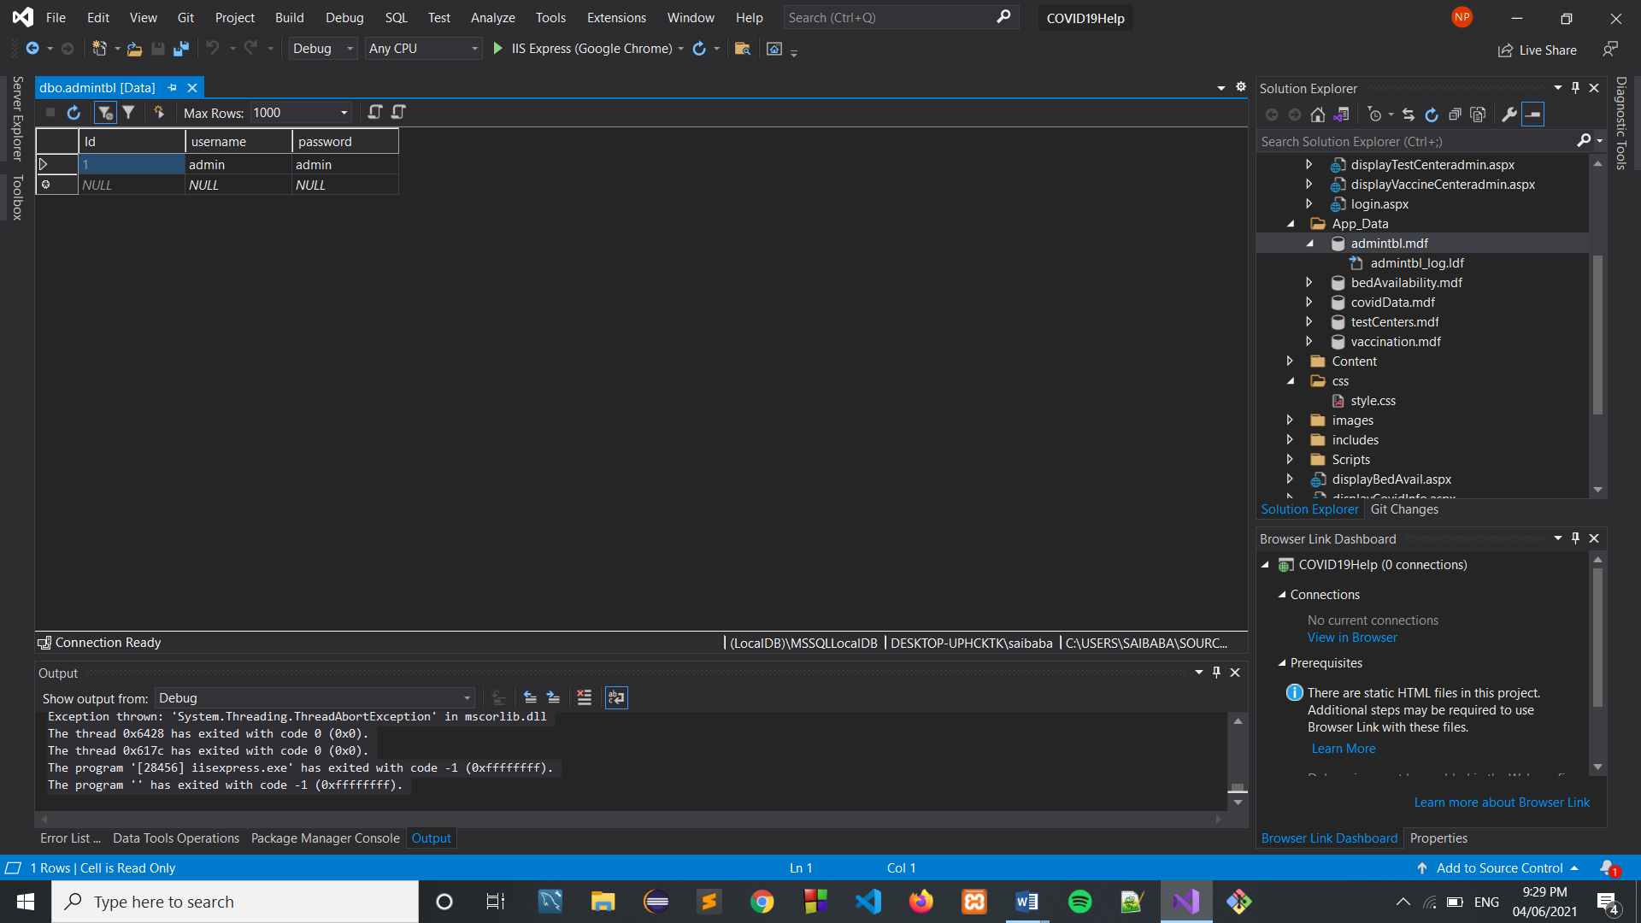

**bedAvailability.mdf**

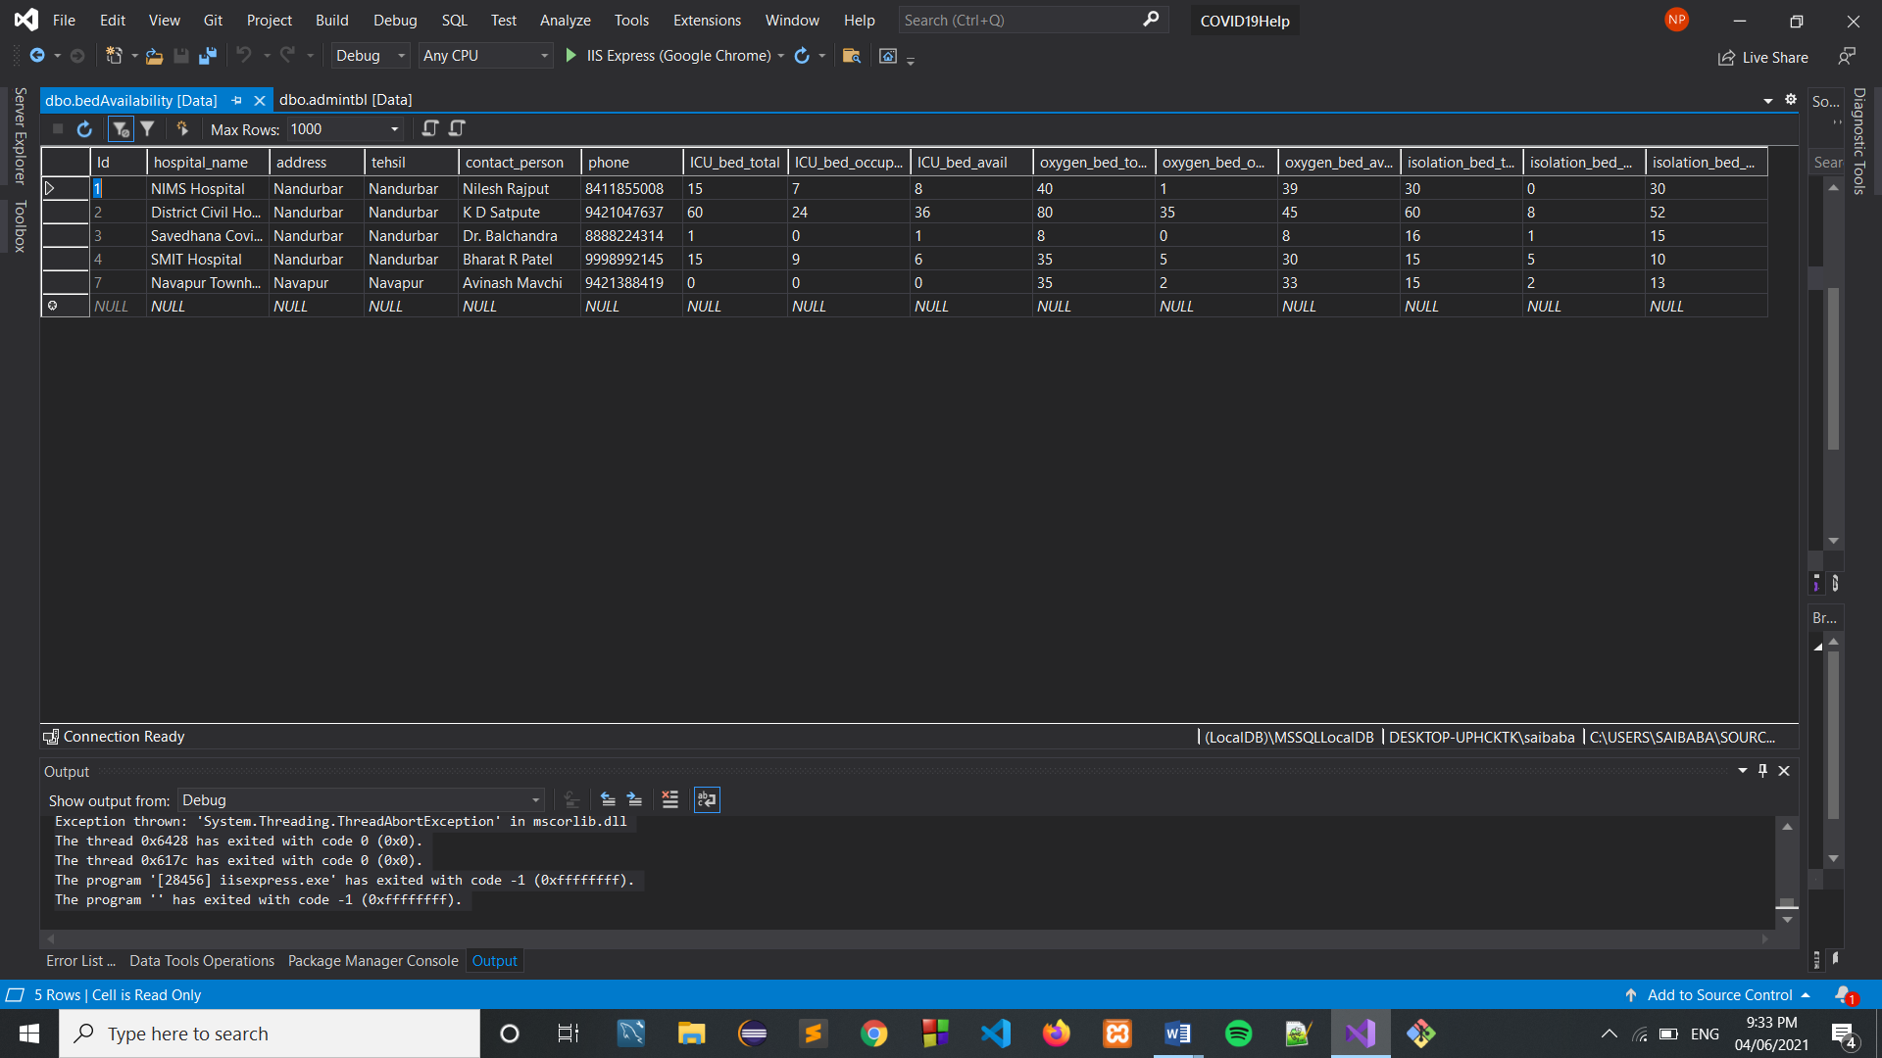

**covidData.mdf**

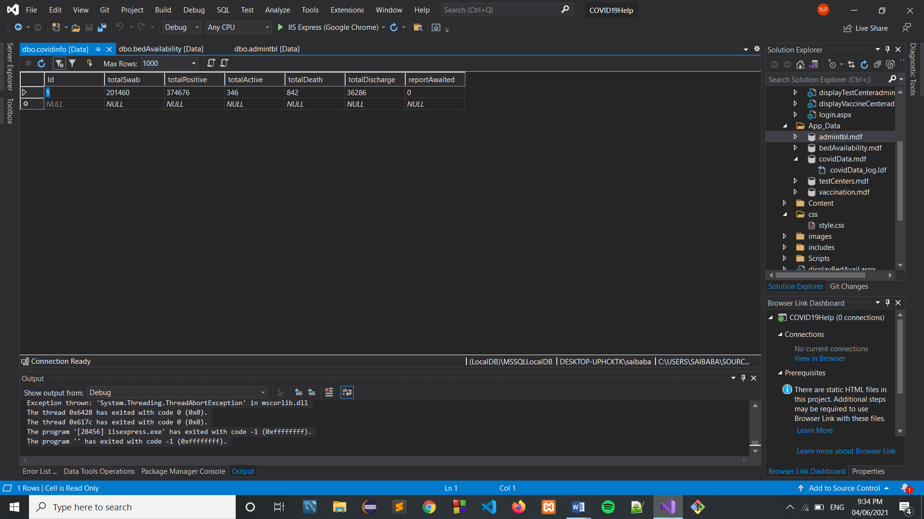

**testCenters.mdf**

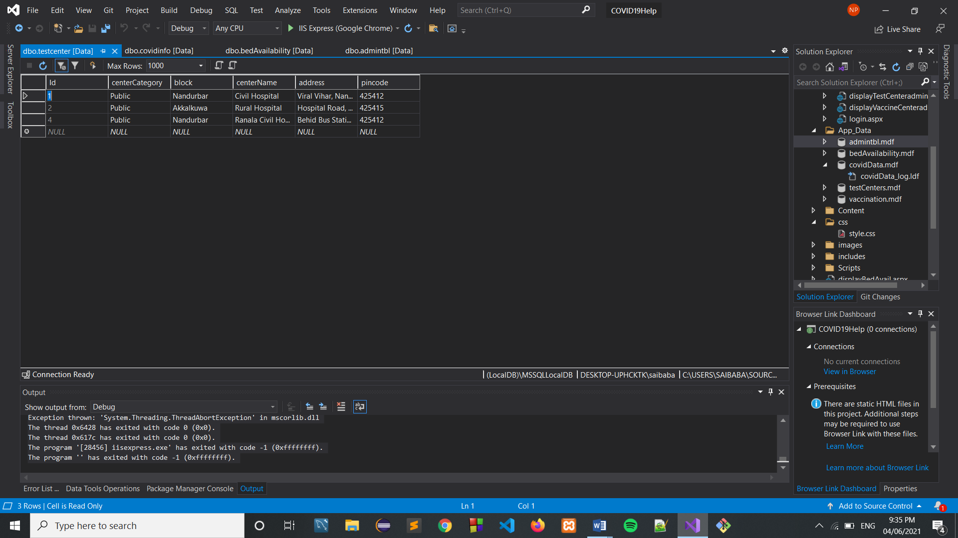

**vaccination.mdf**

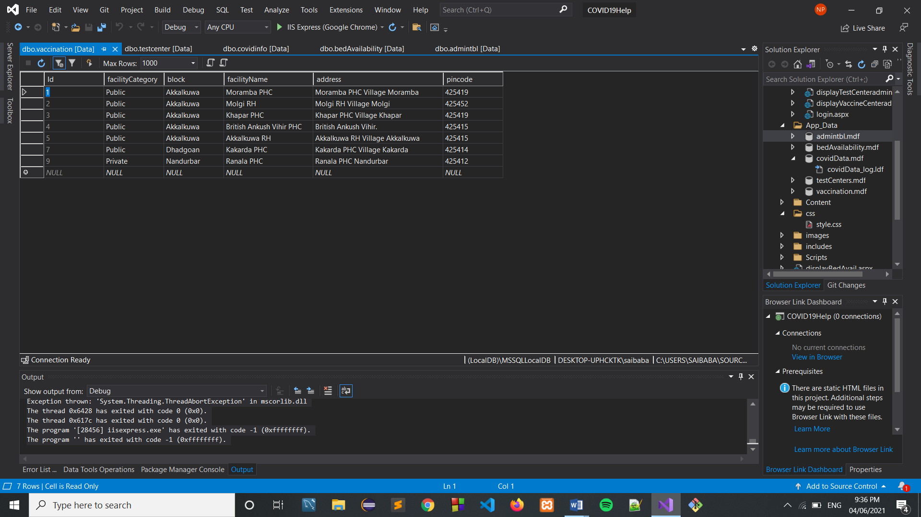

**Output:**

**index.html ->**



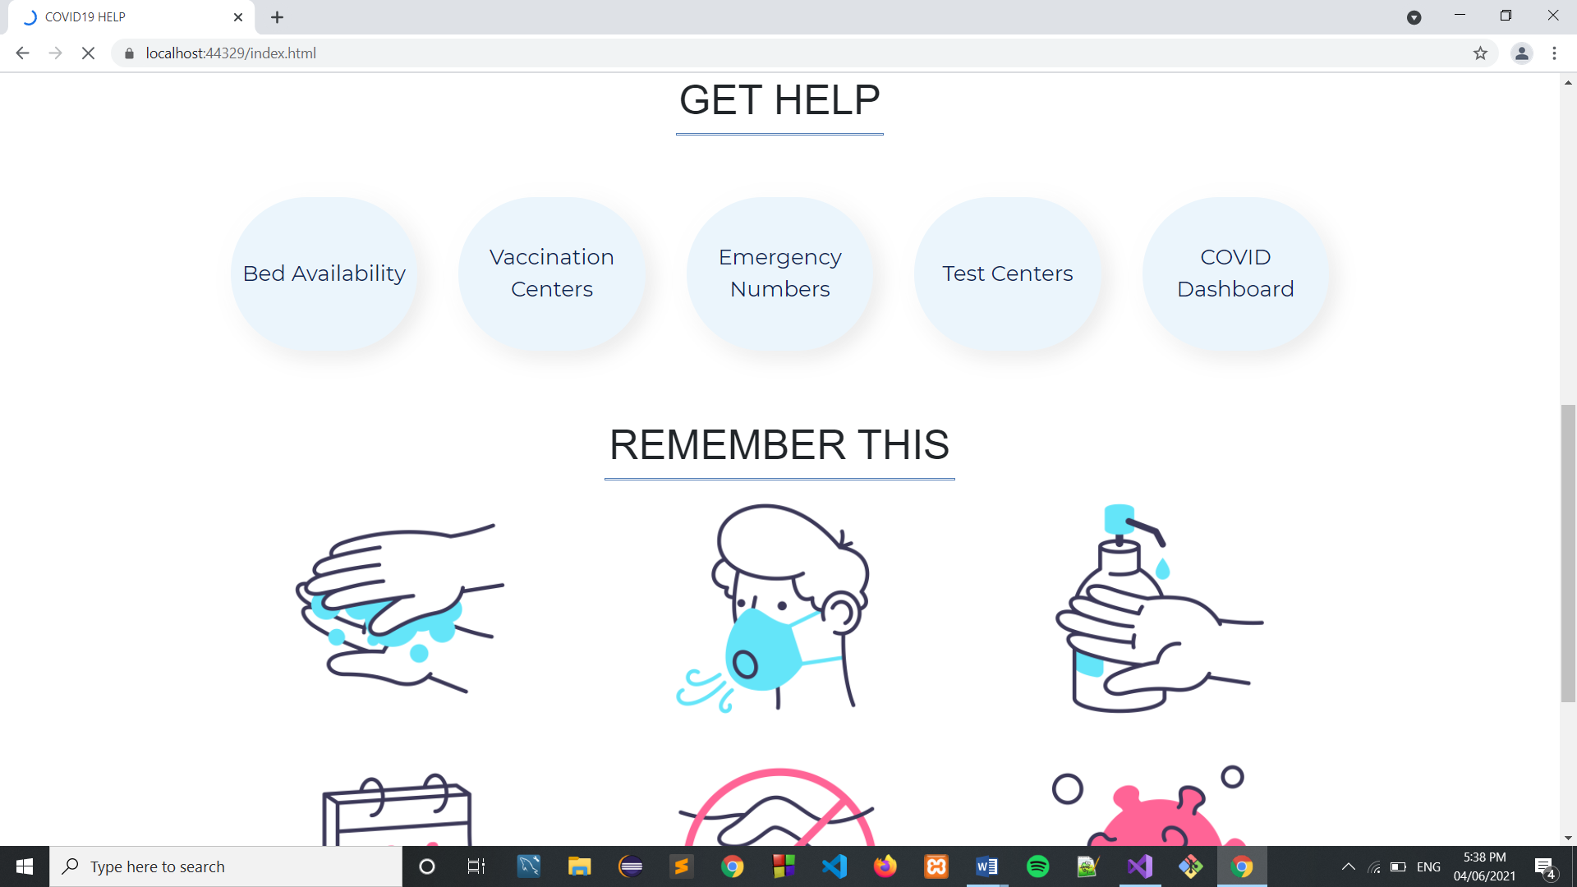

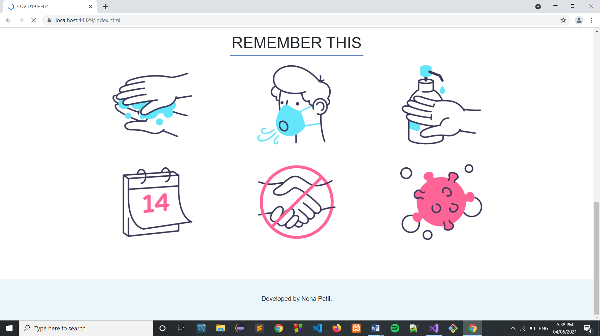

**Bed Availability ->**

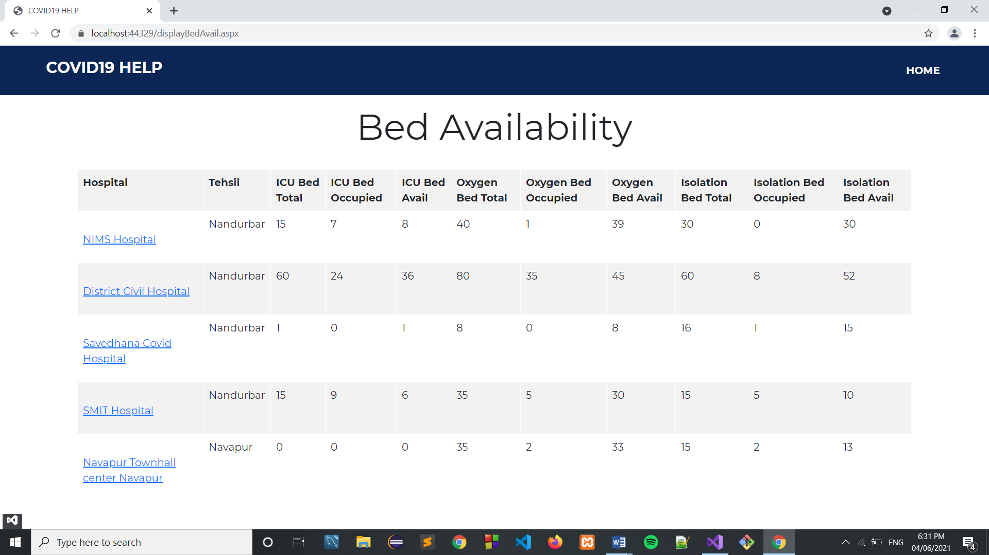

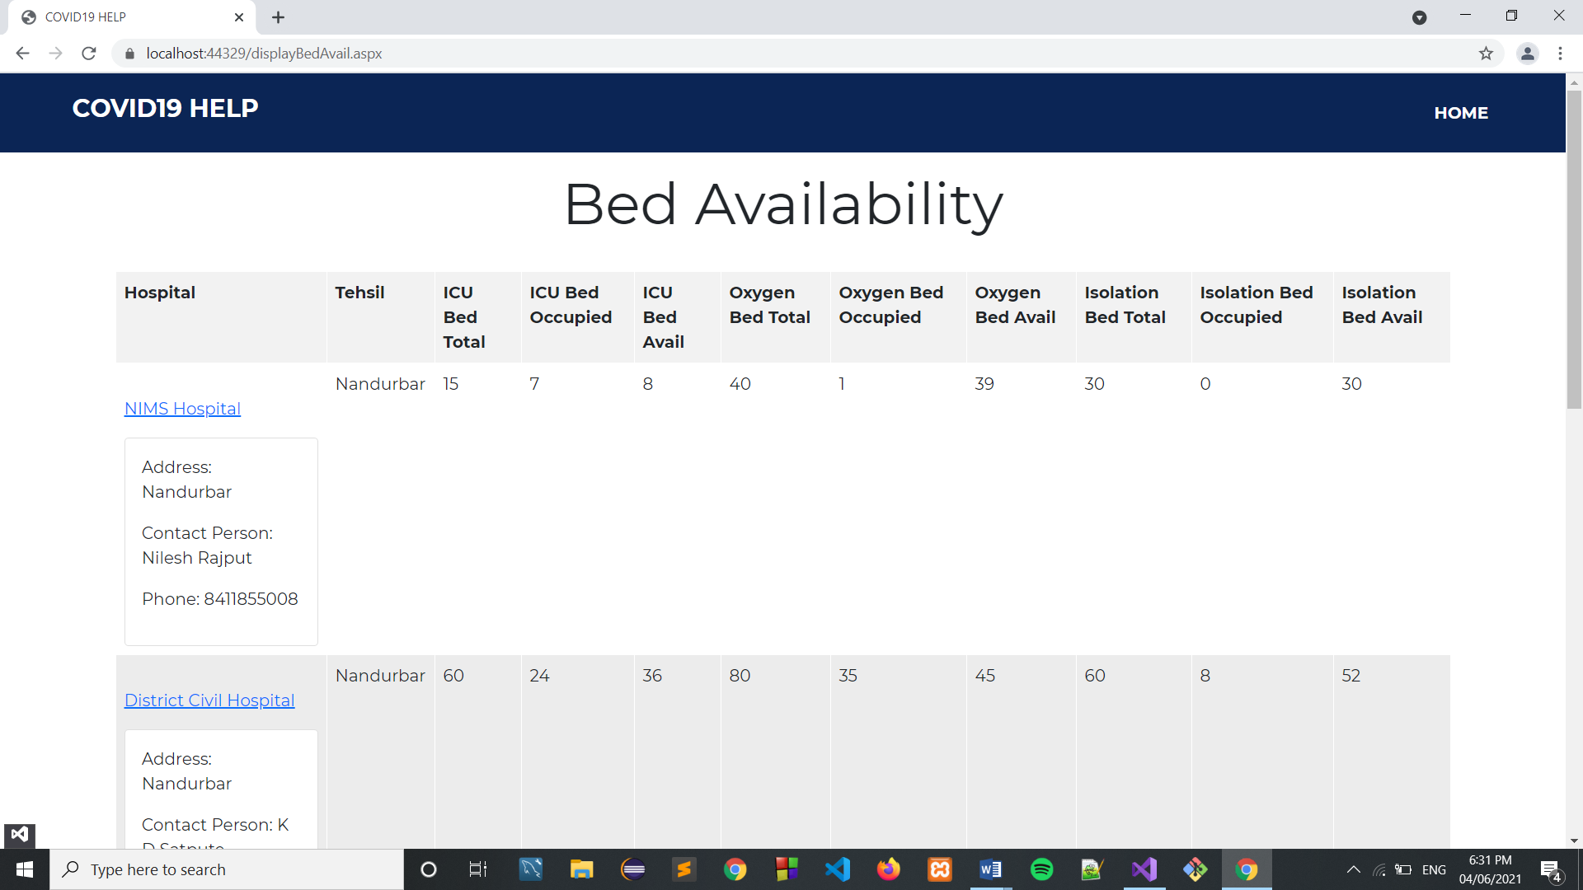

**Vaccination Centers ->**

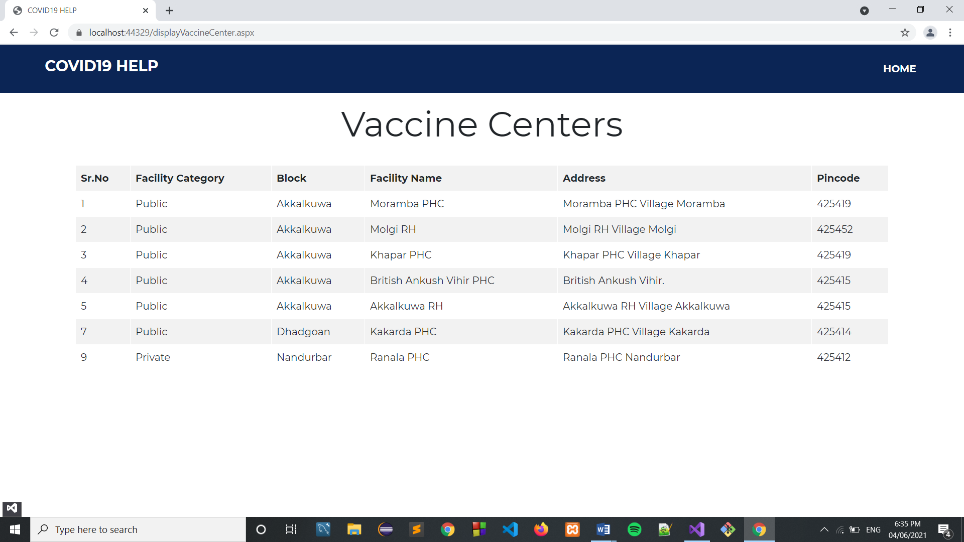

**Emergency Numbers ->**

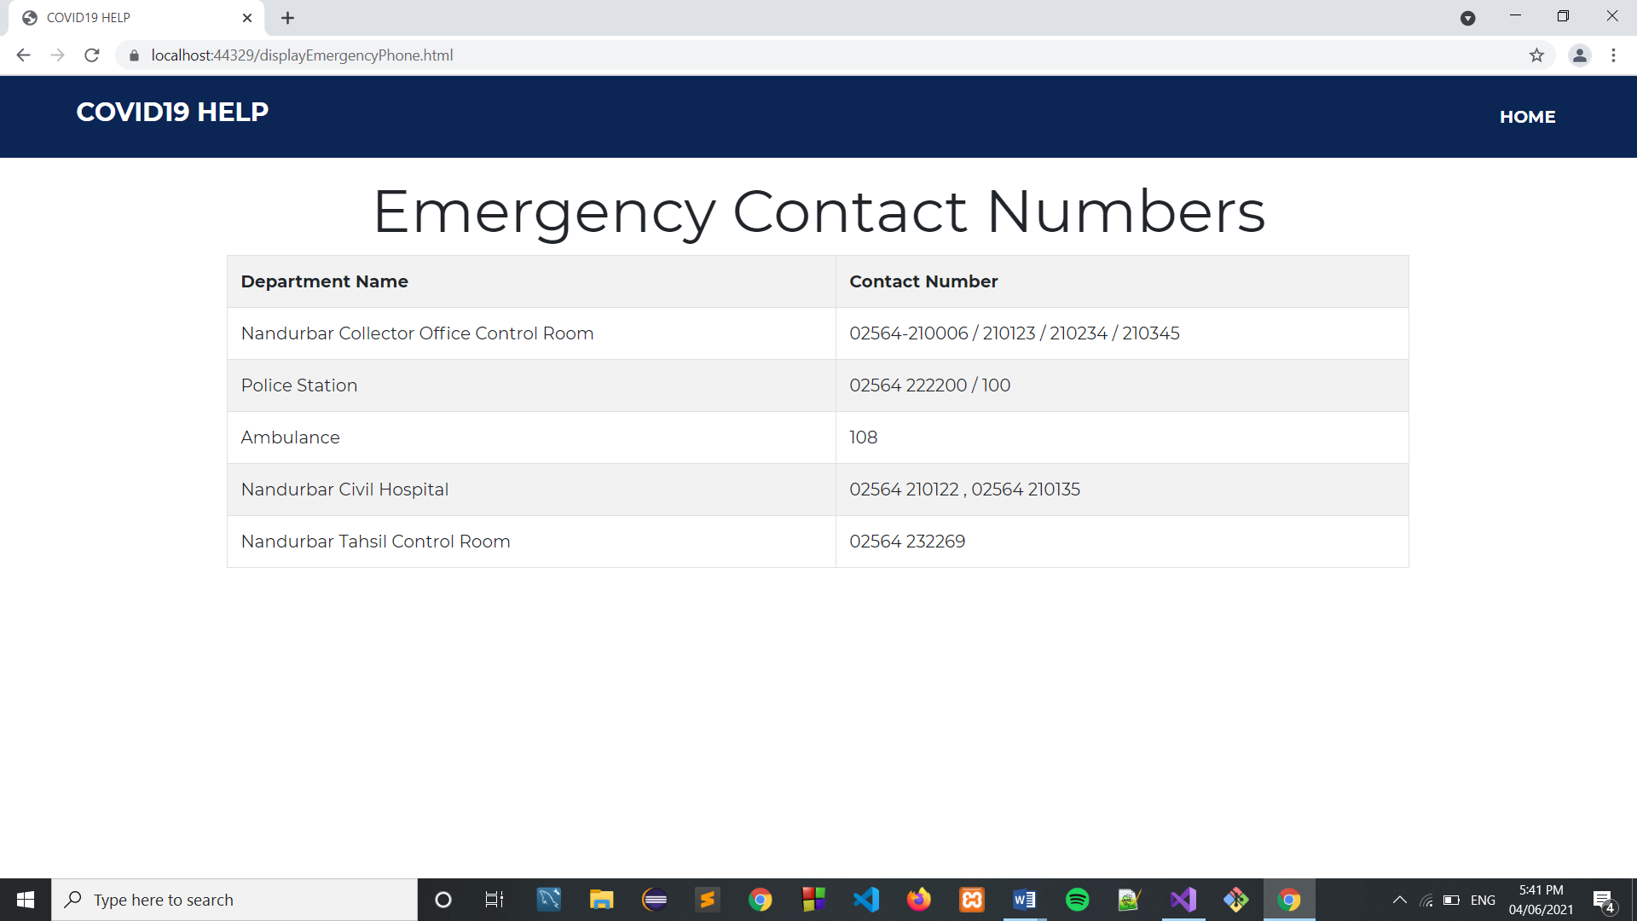

**Test Center ->**

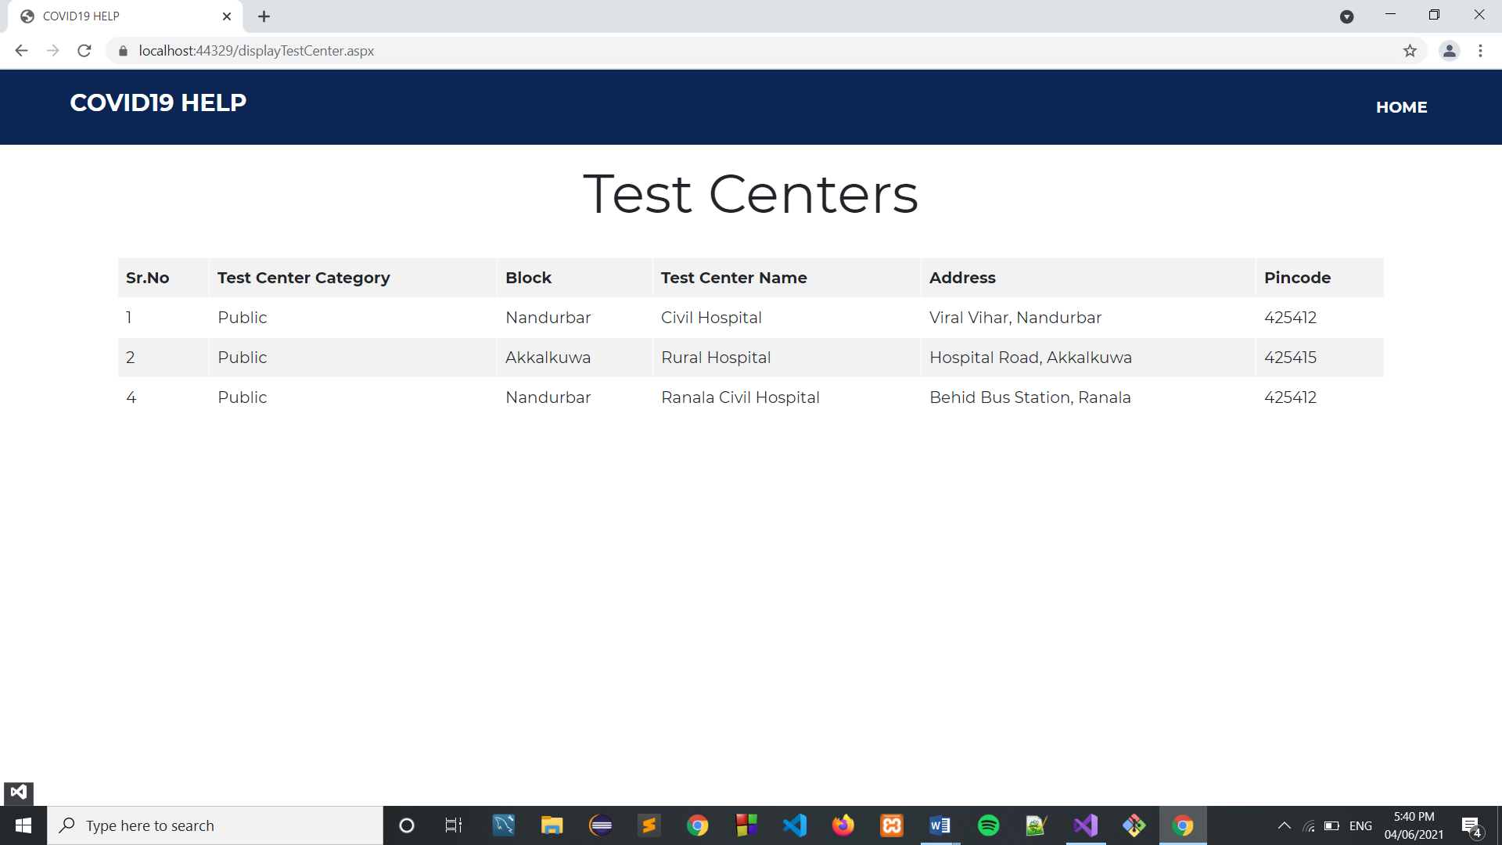

**COVID19 Dashboard ->**

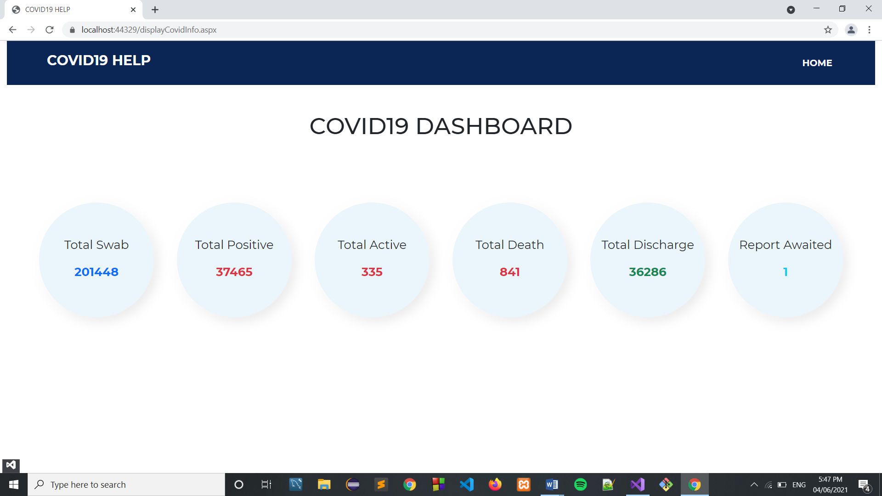

**Admin login ->**

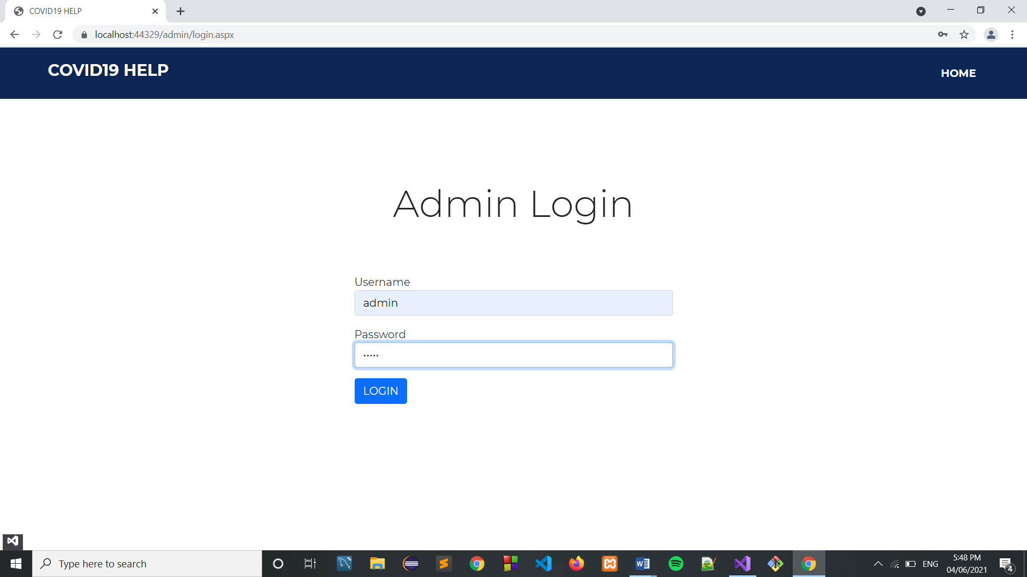

**Admin dashboard ->**

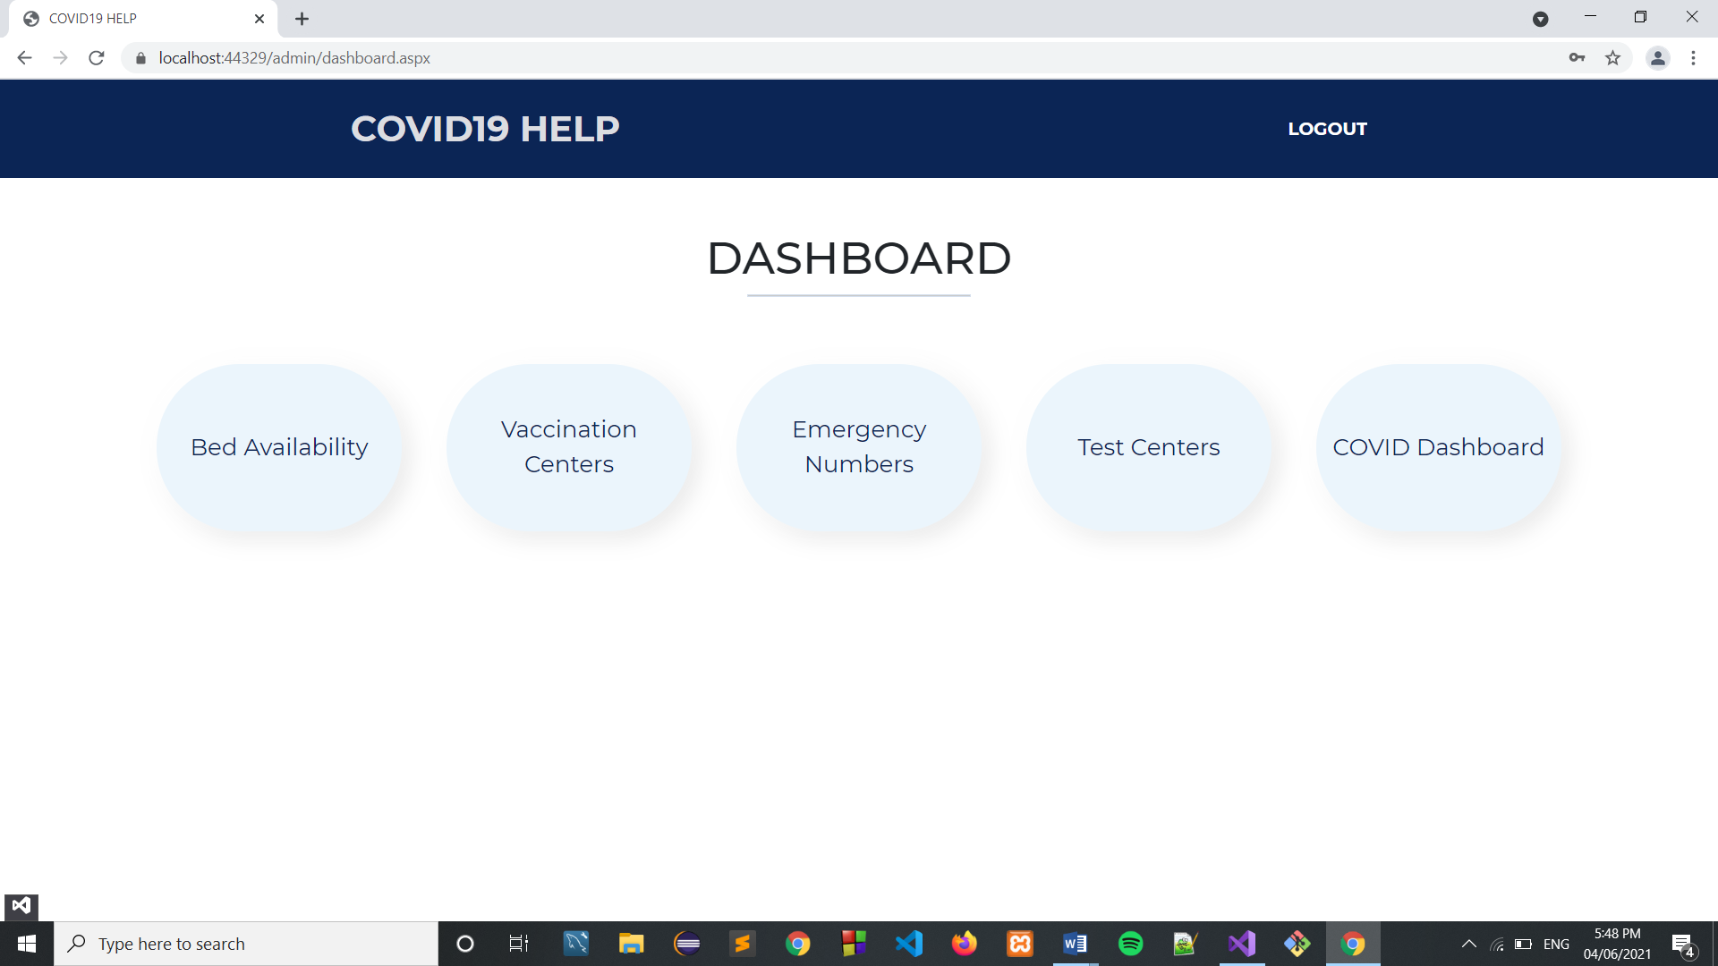

**Add, Update, Delete Bed Availability data ->**

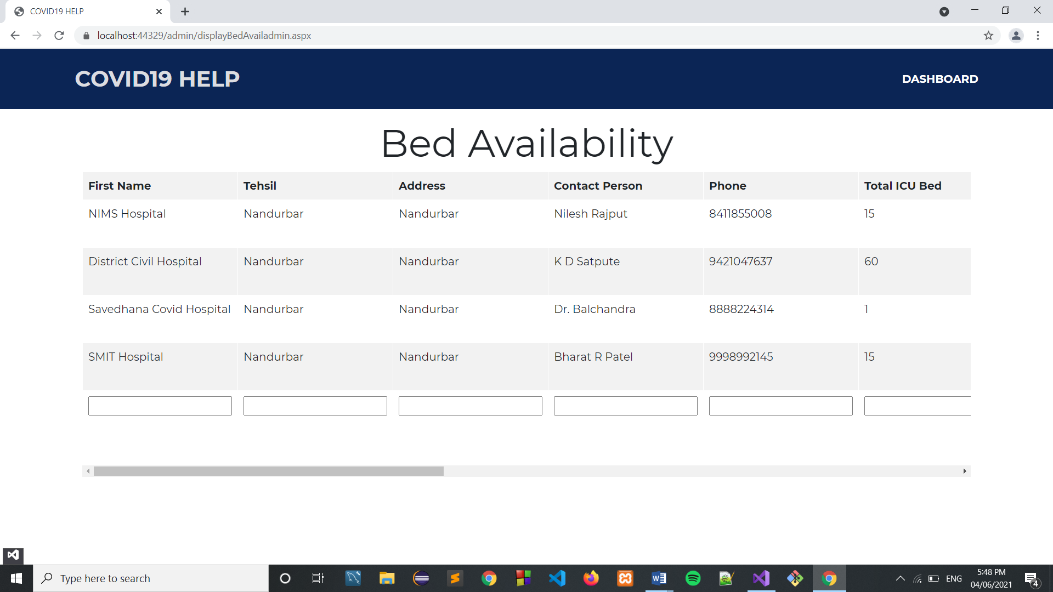

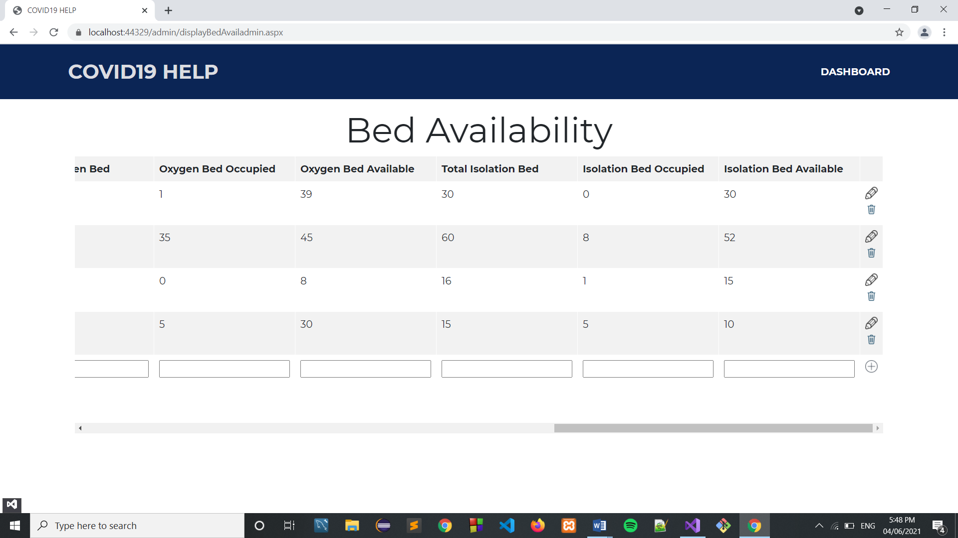

**Adding hospital bed availability ->**

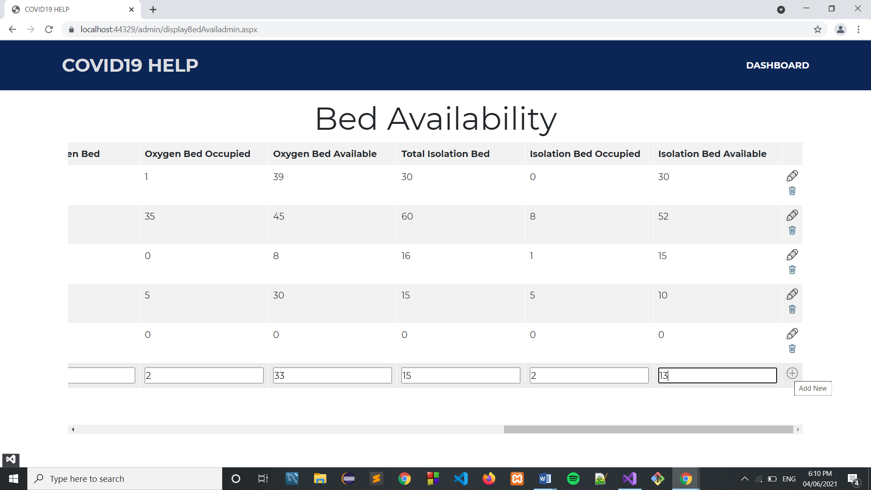

**After adding ->**

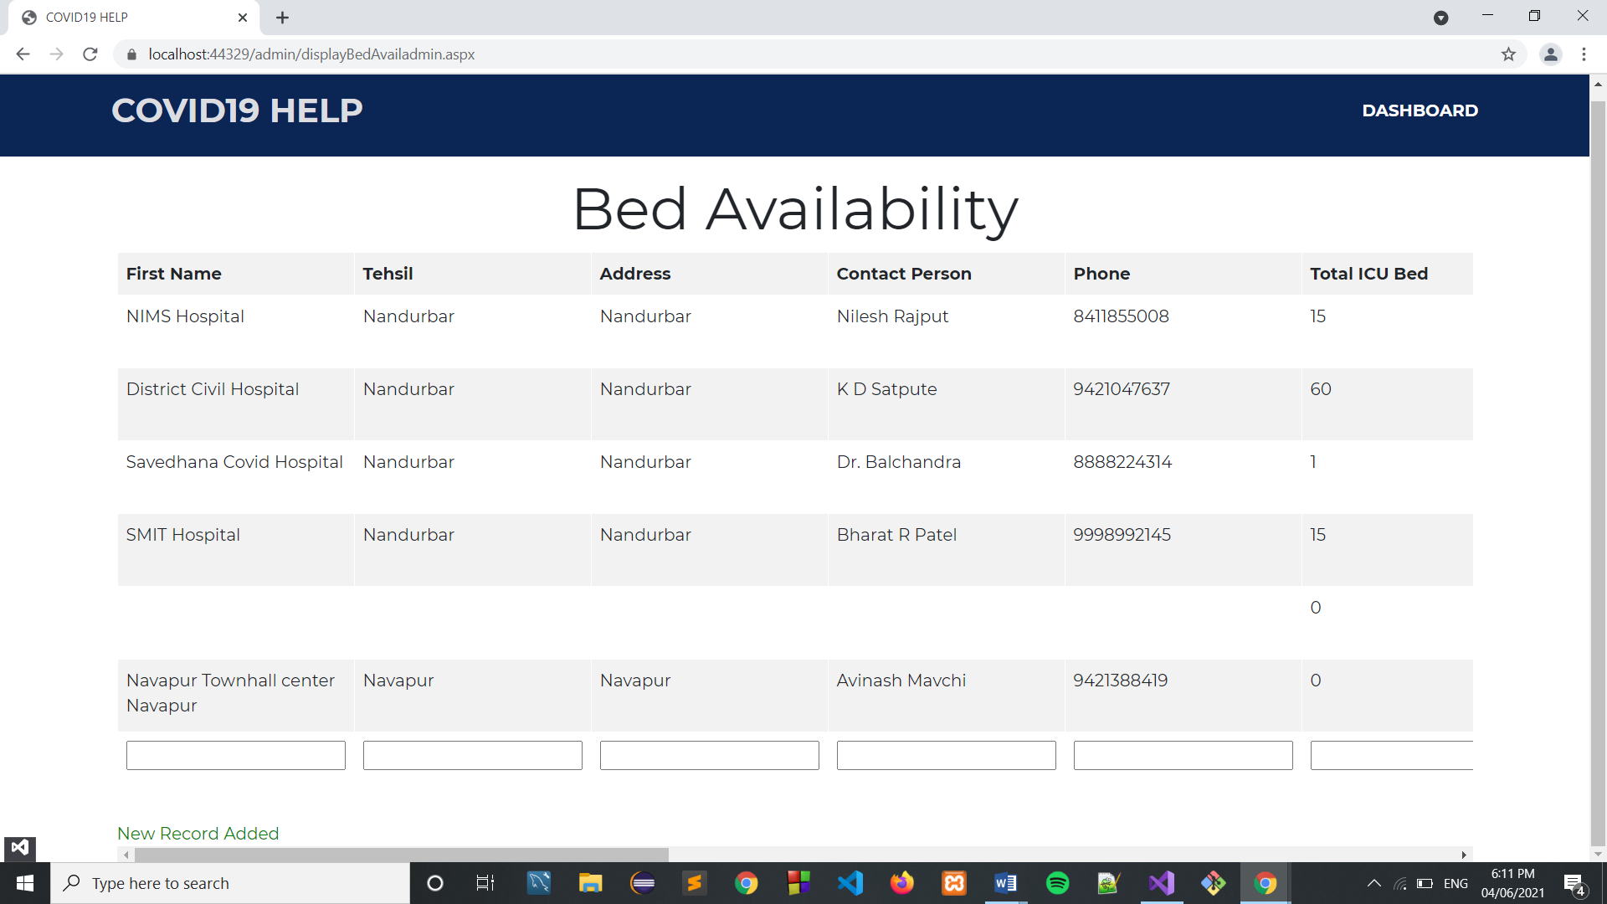

**Deleting data ->**

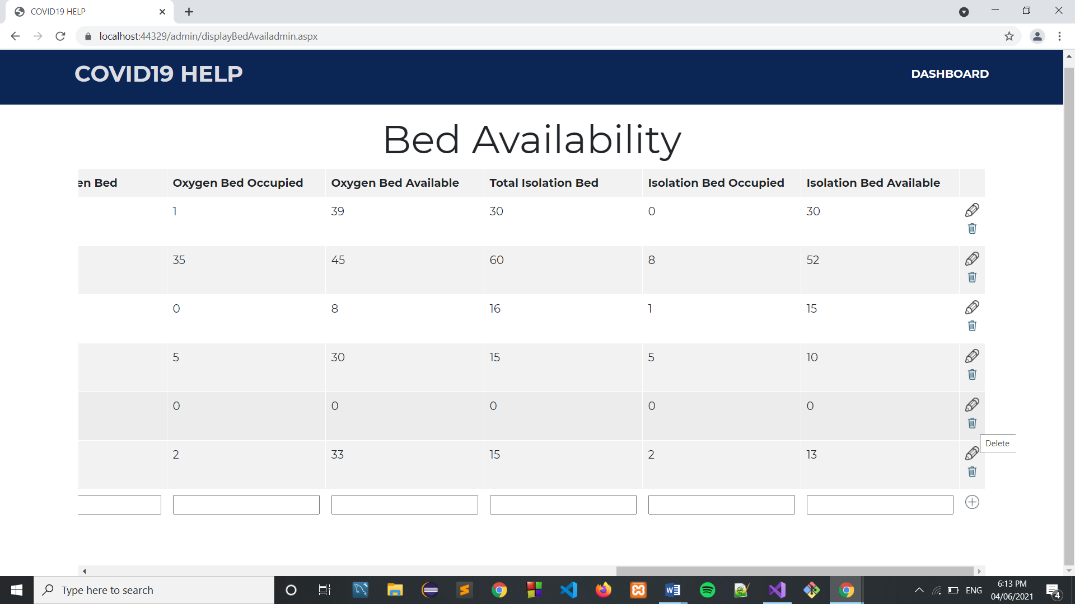

**After deleting ->**

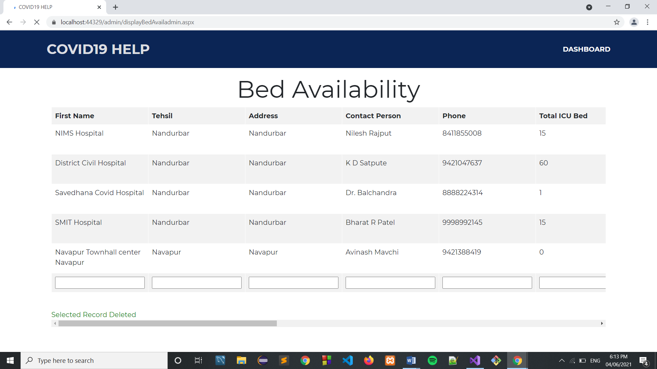

**Vaccine center data ->**

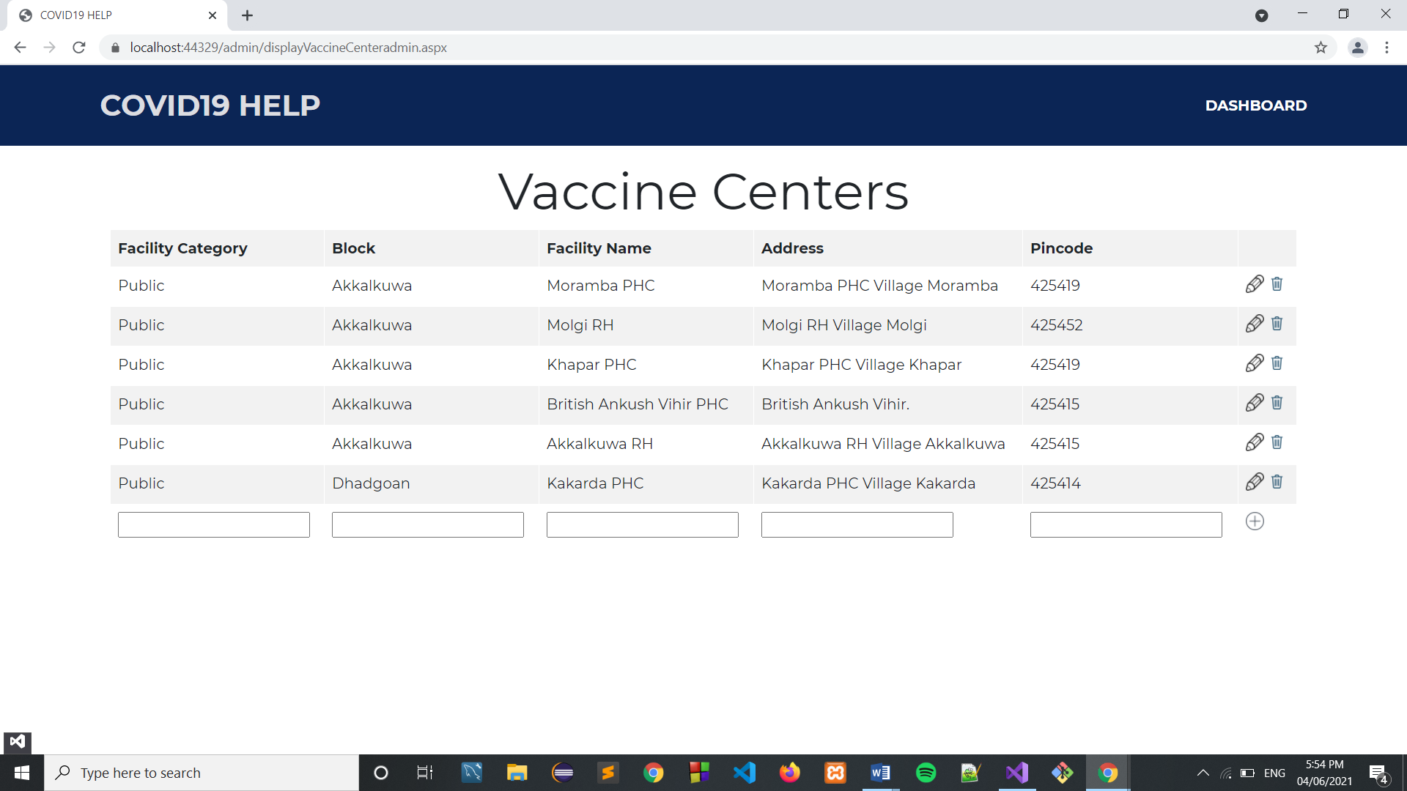

**Add Vaccine Center ->**

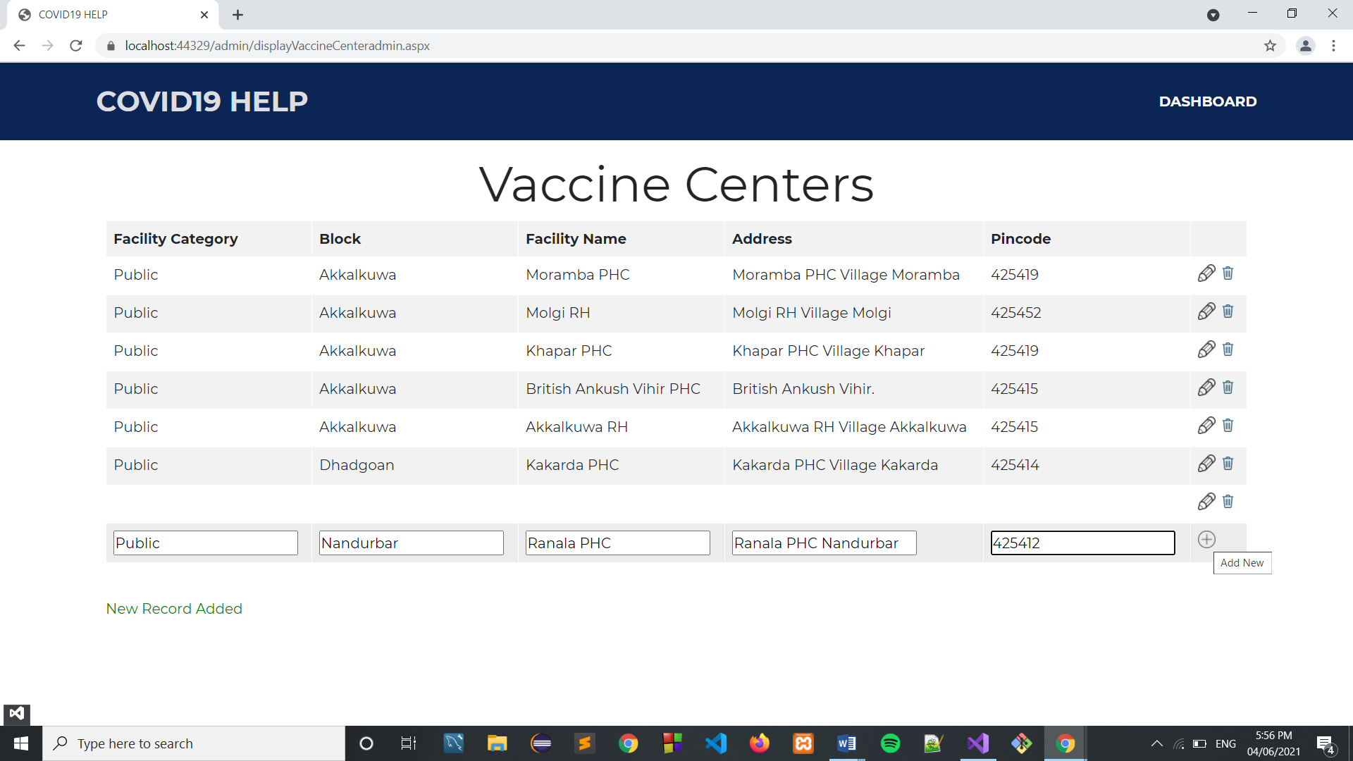

**After adding ->**

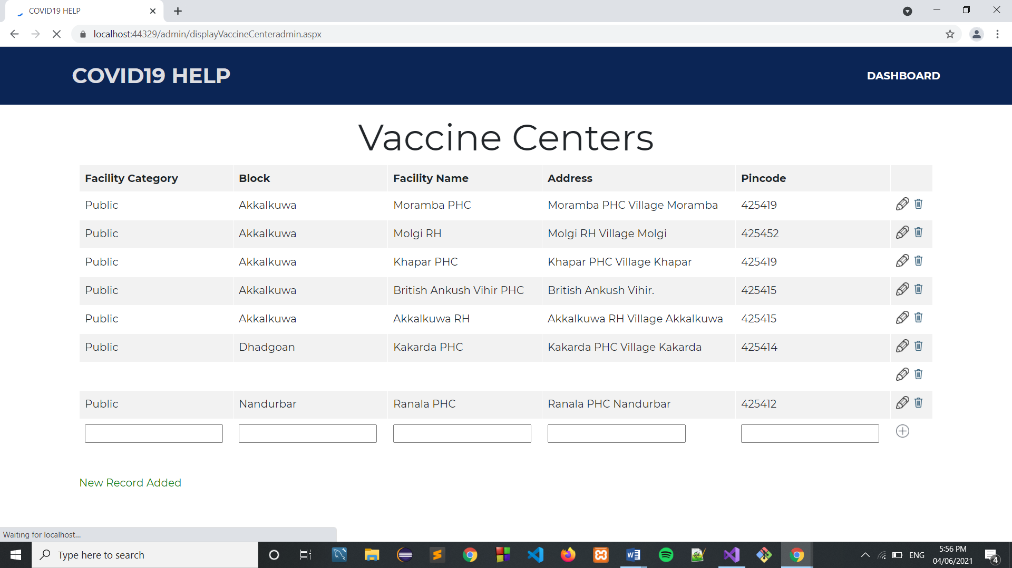

**Updating center ->**

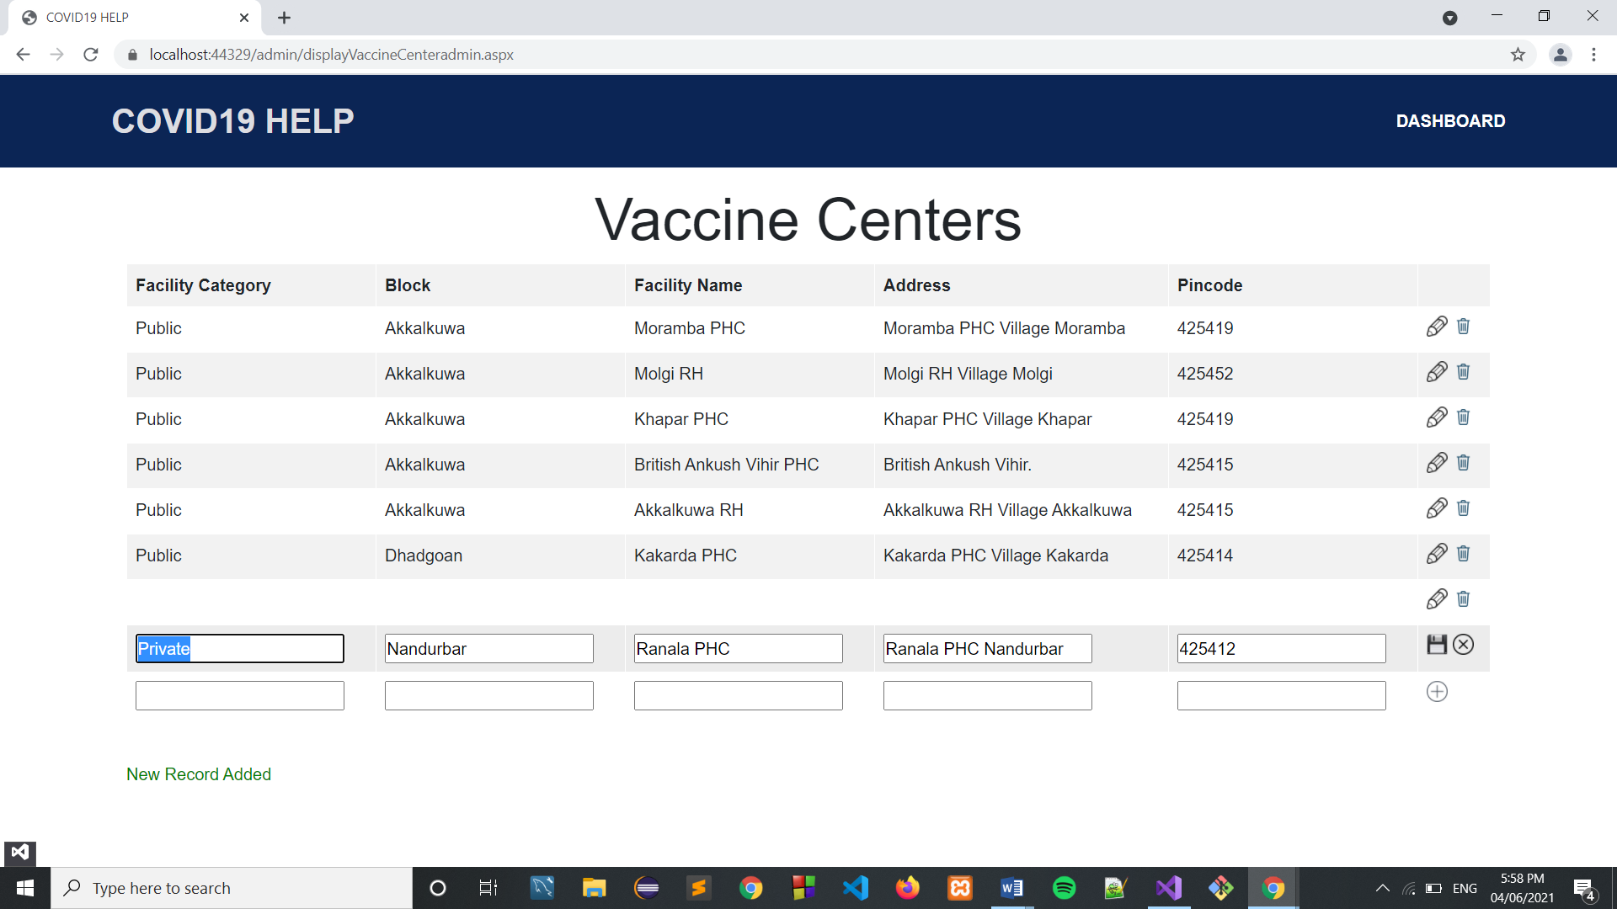

**After Updating ->**

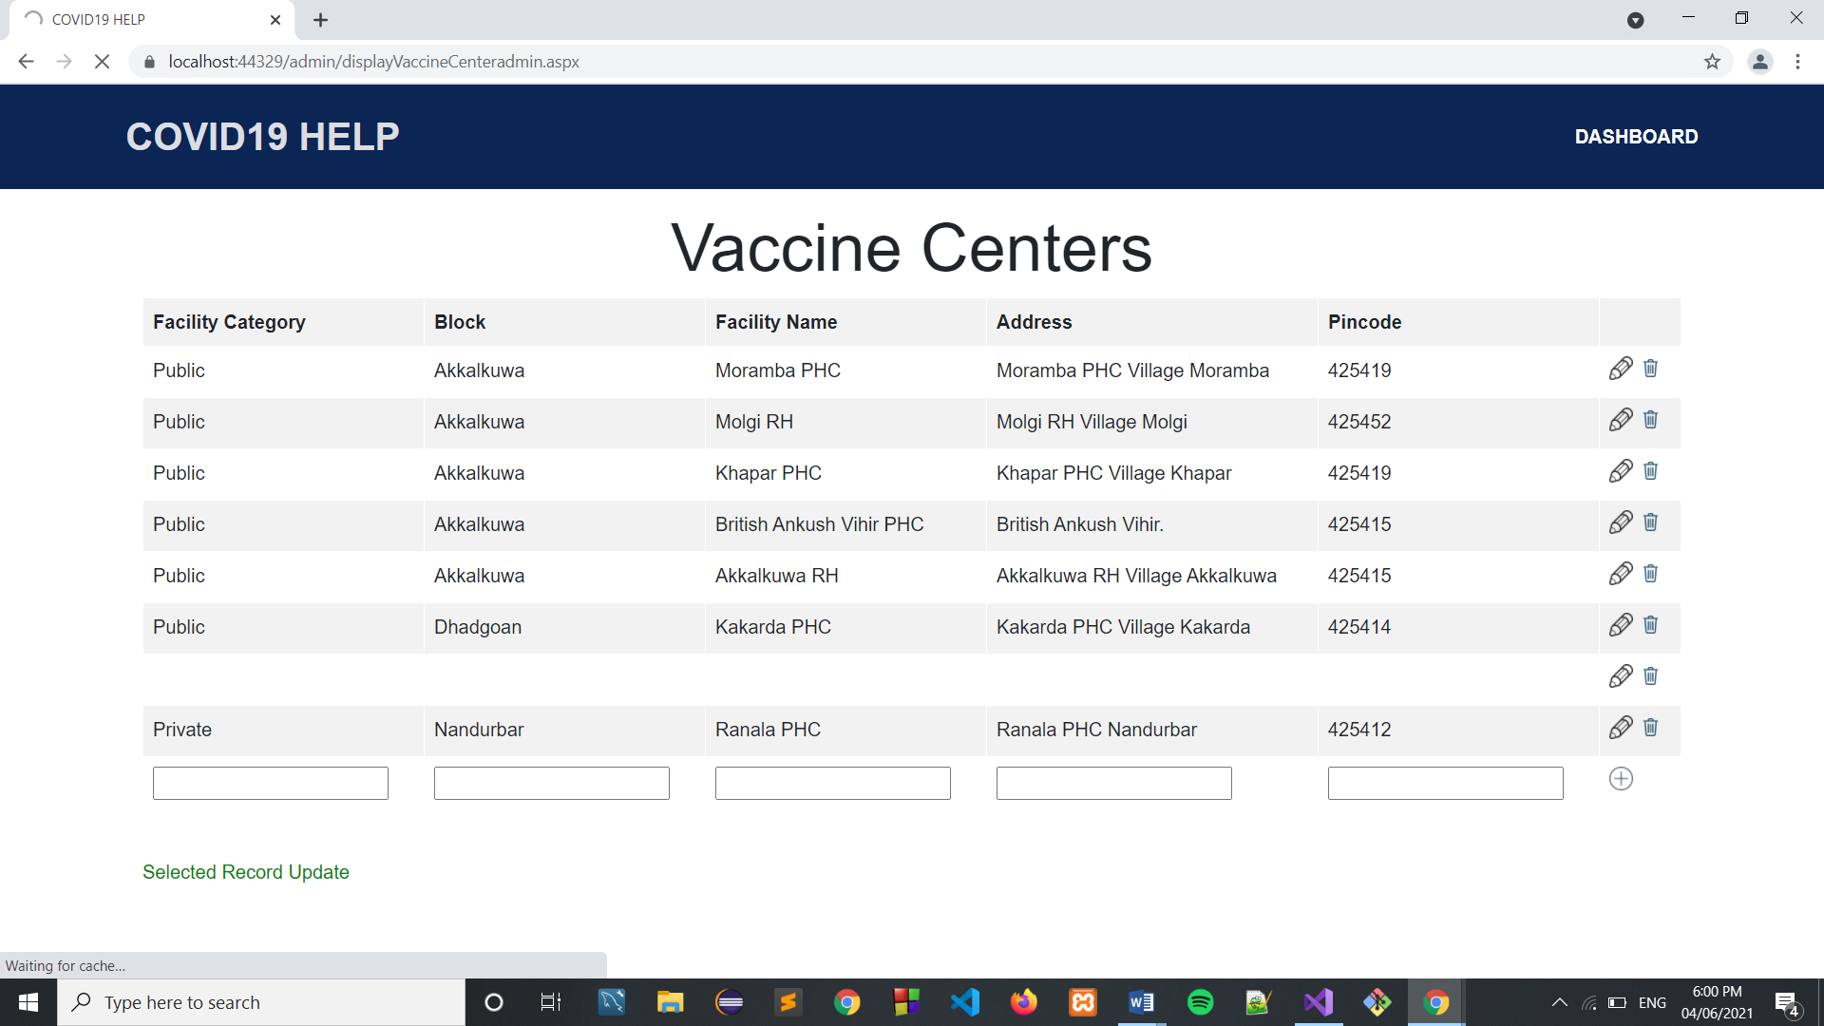

**Deleting ->**

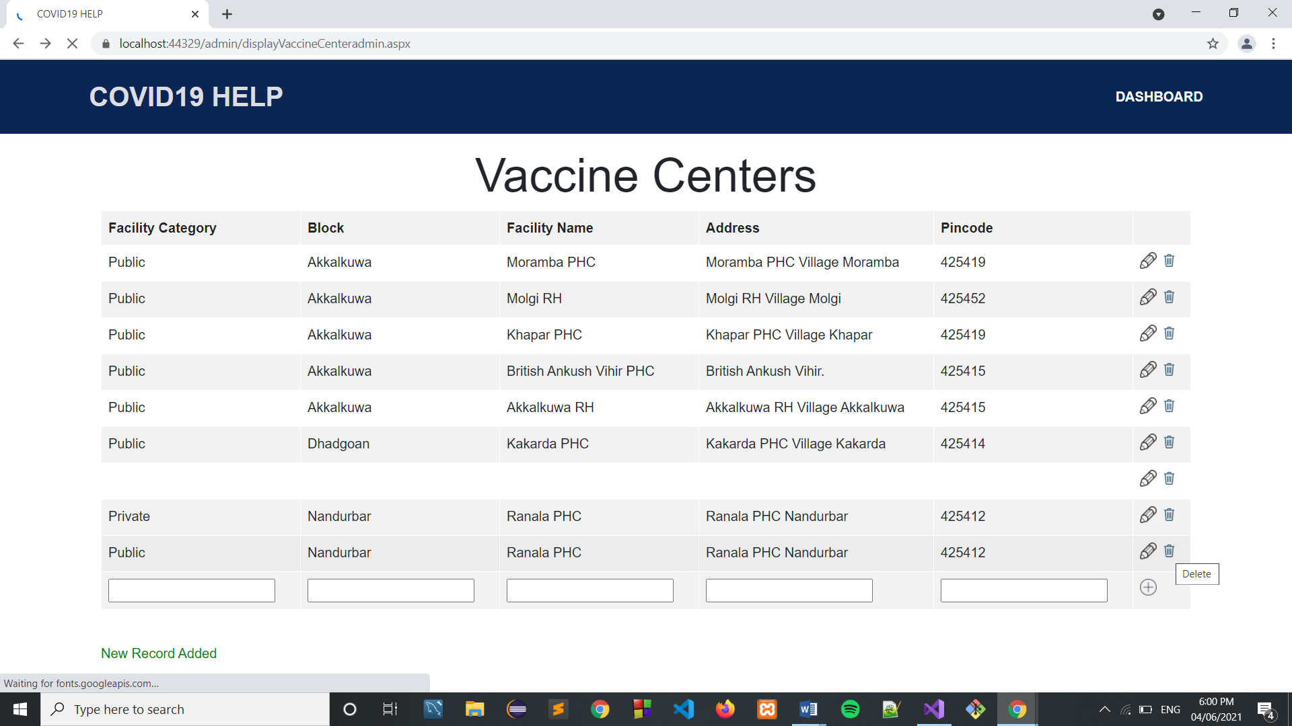

**After Deleting ->**

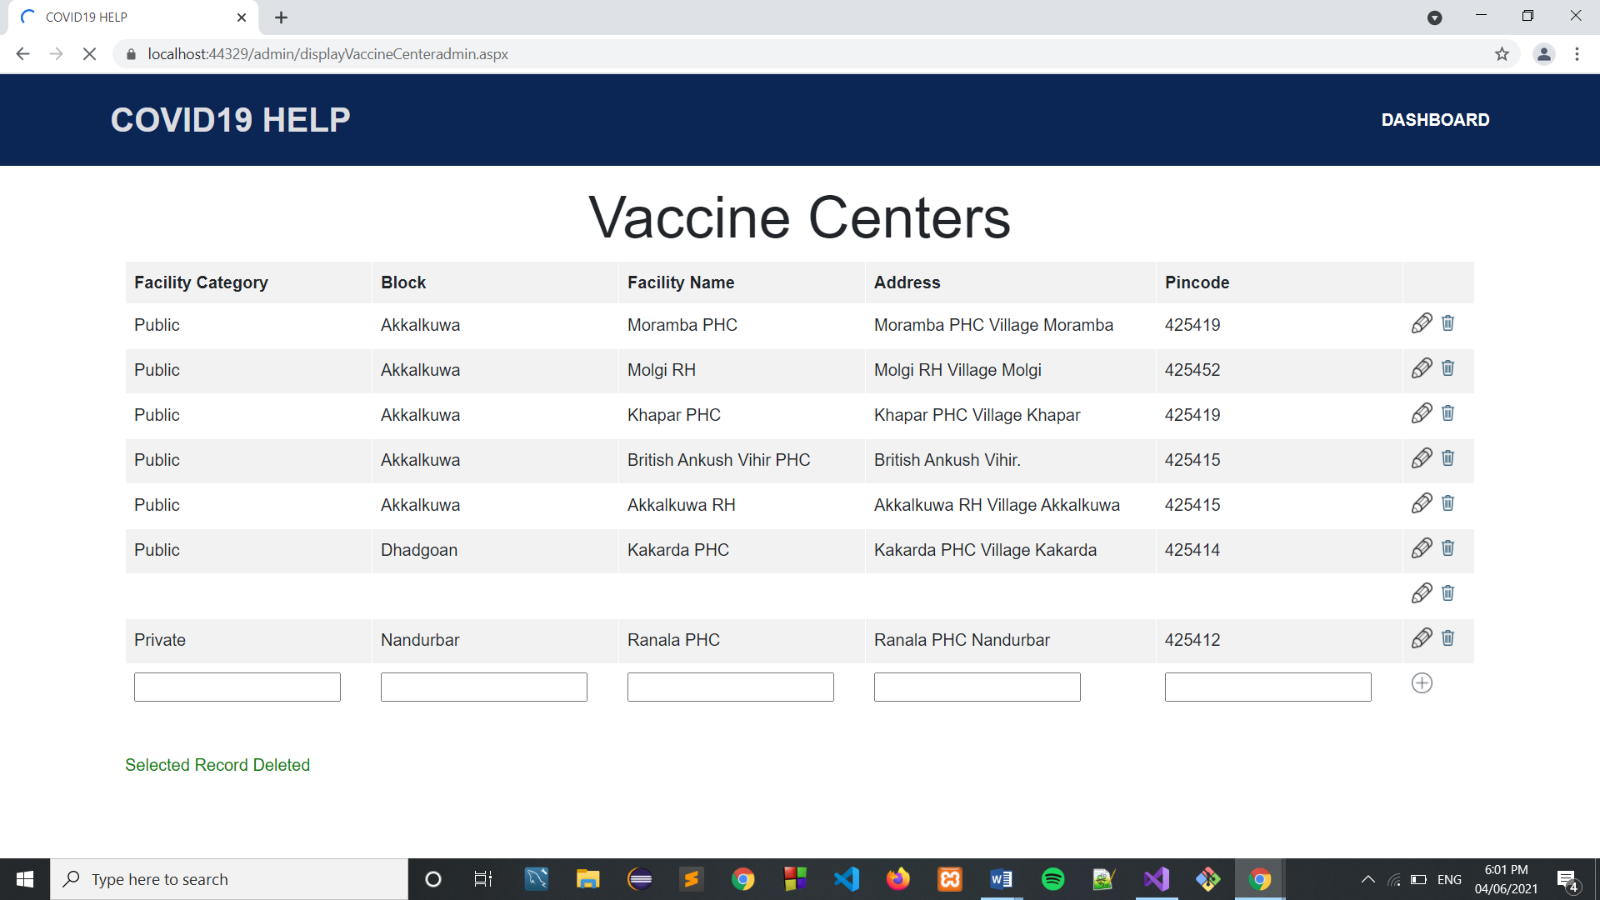

**Test Centers ->**

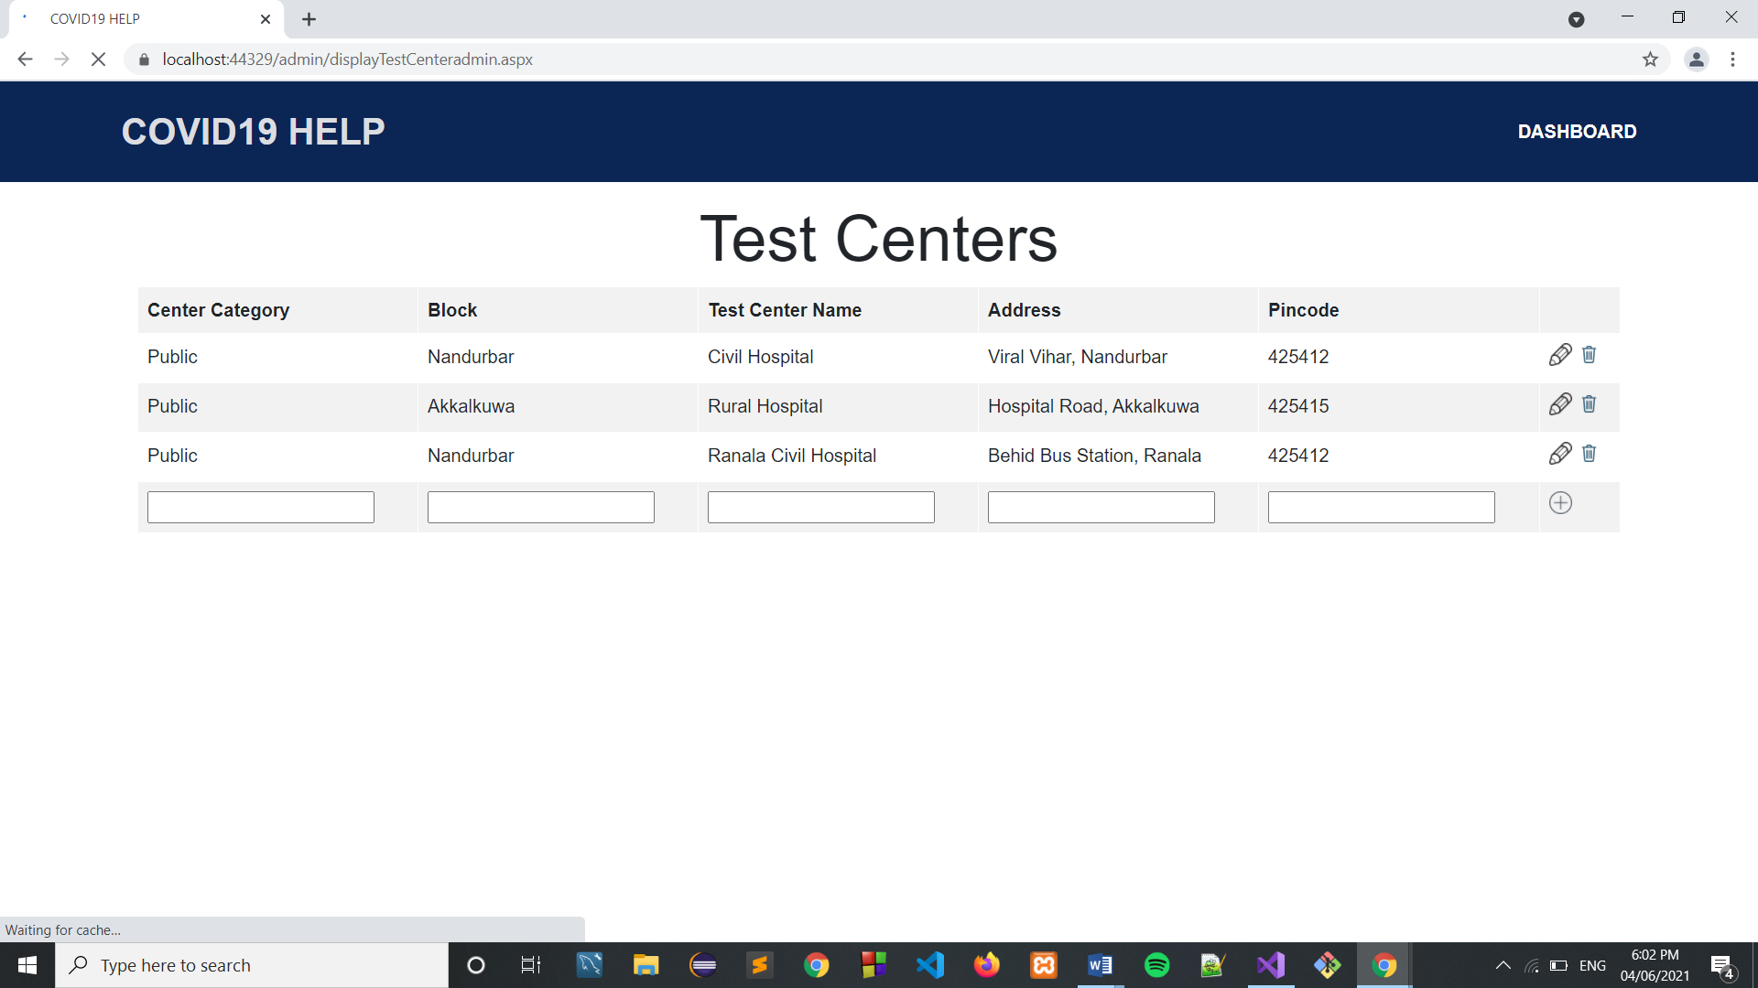

**Adding Test Center ->**

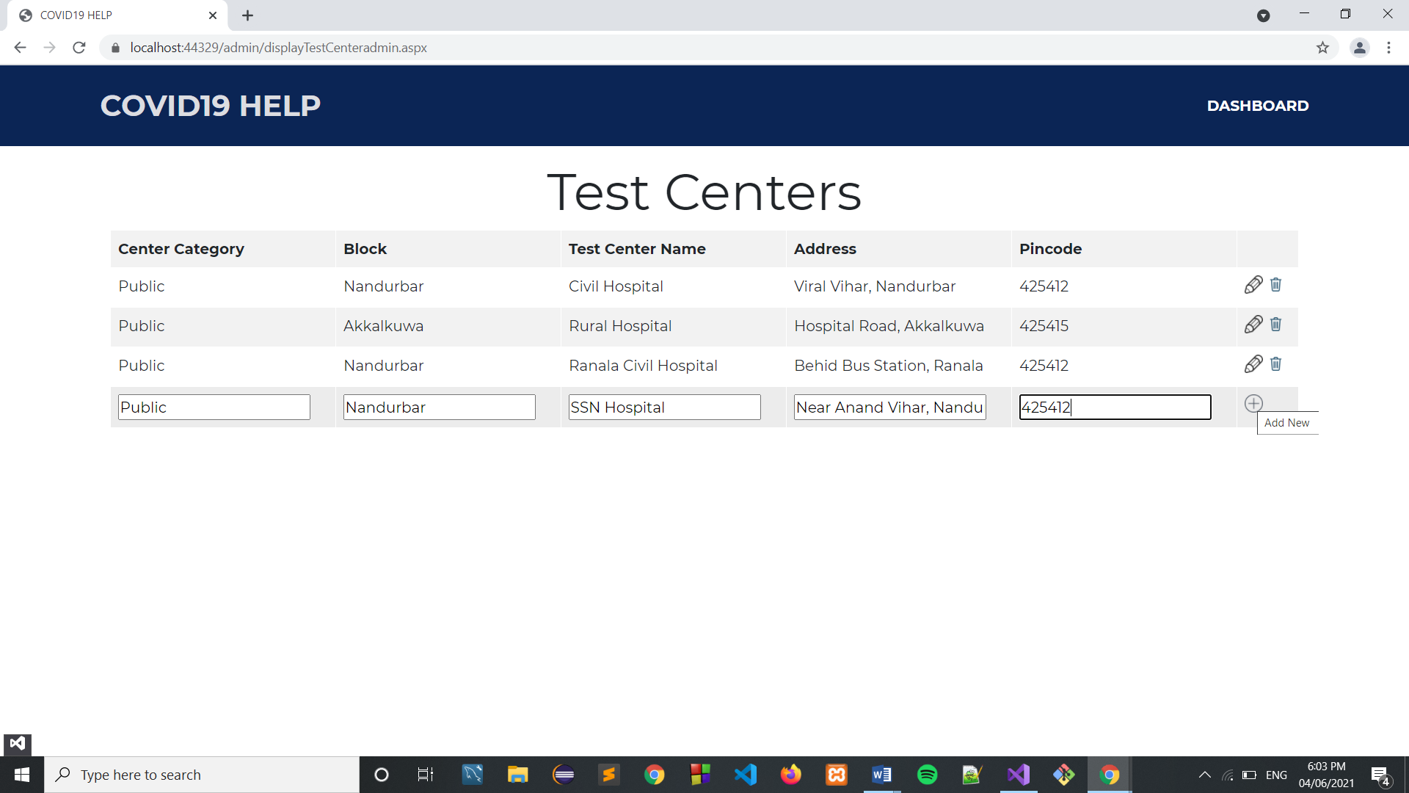

**After Adding ->**

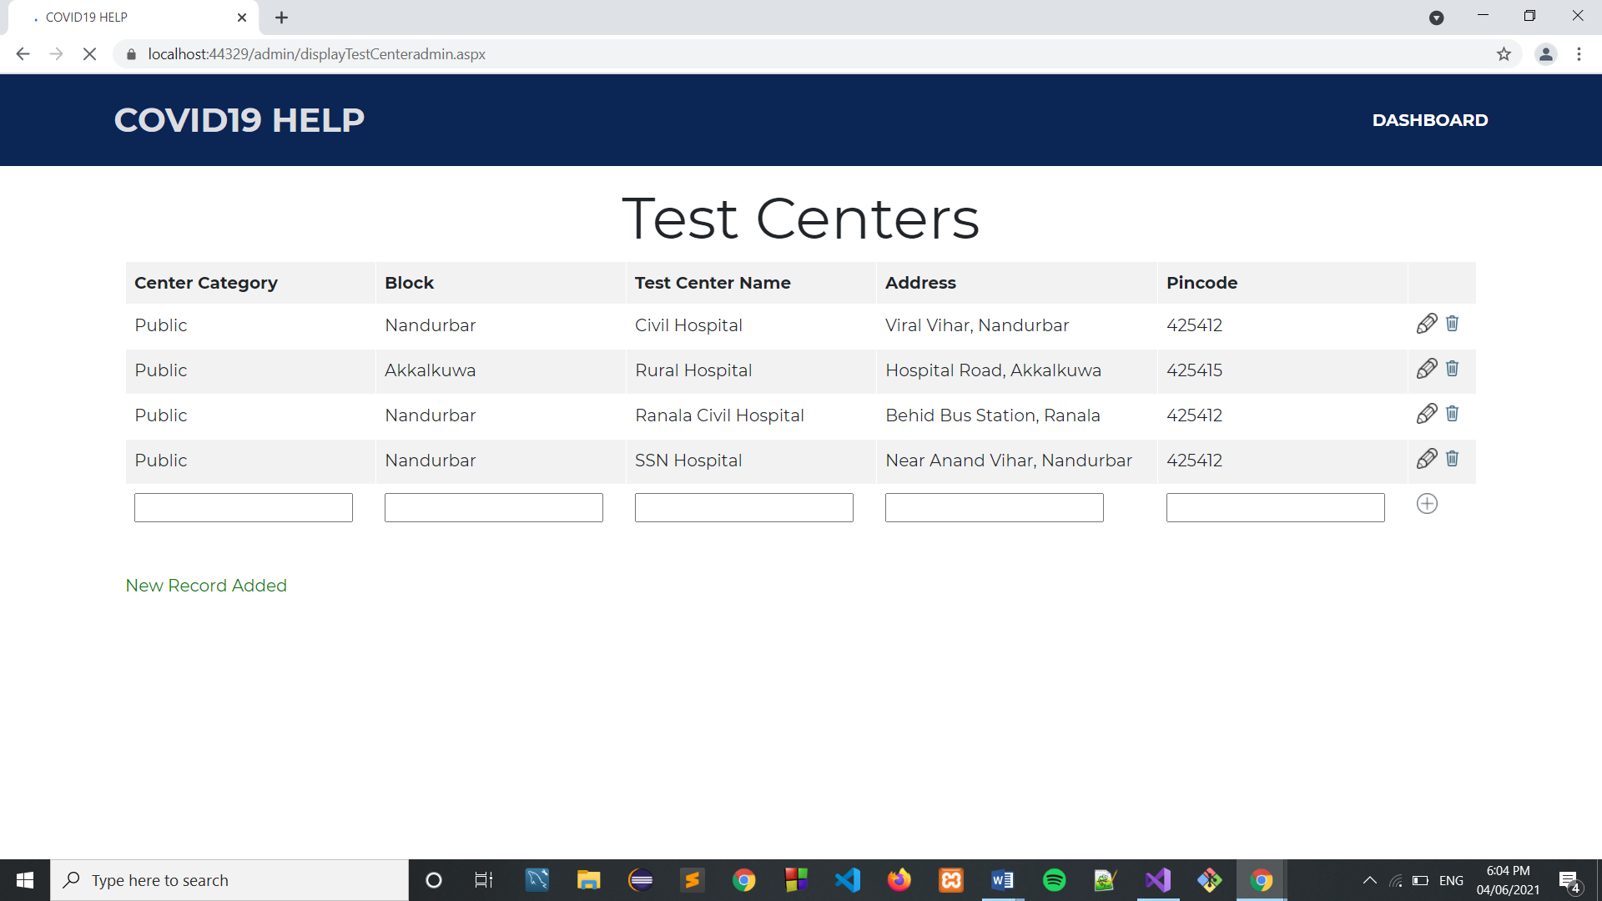

**Updating Test Center ->**

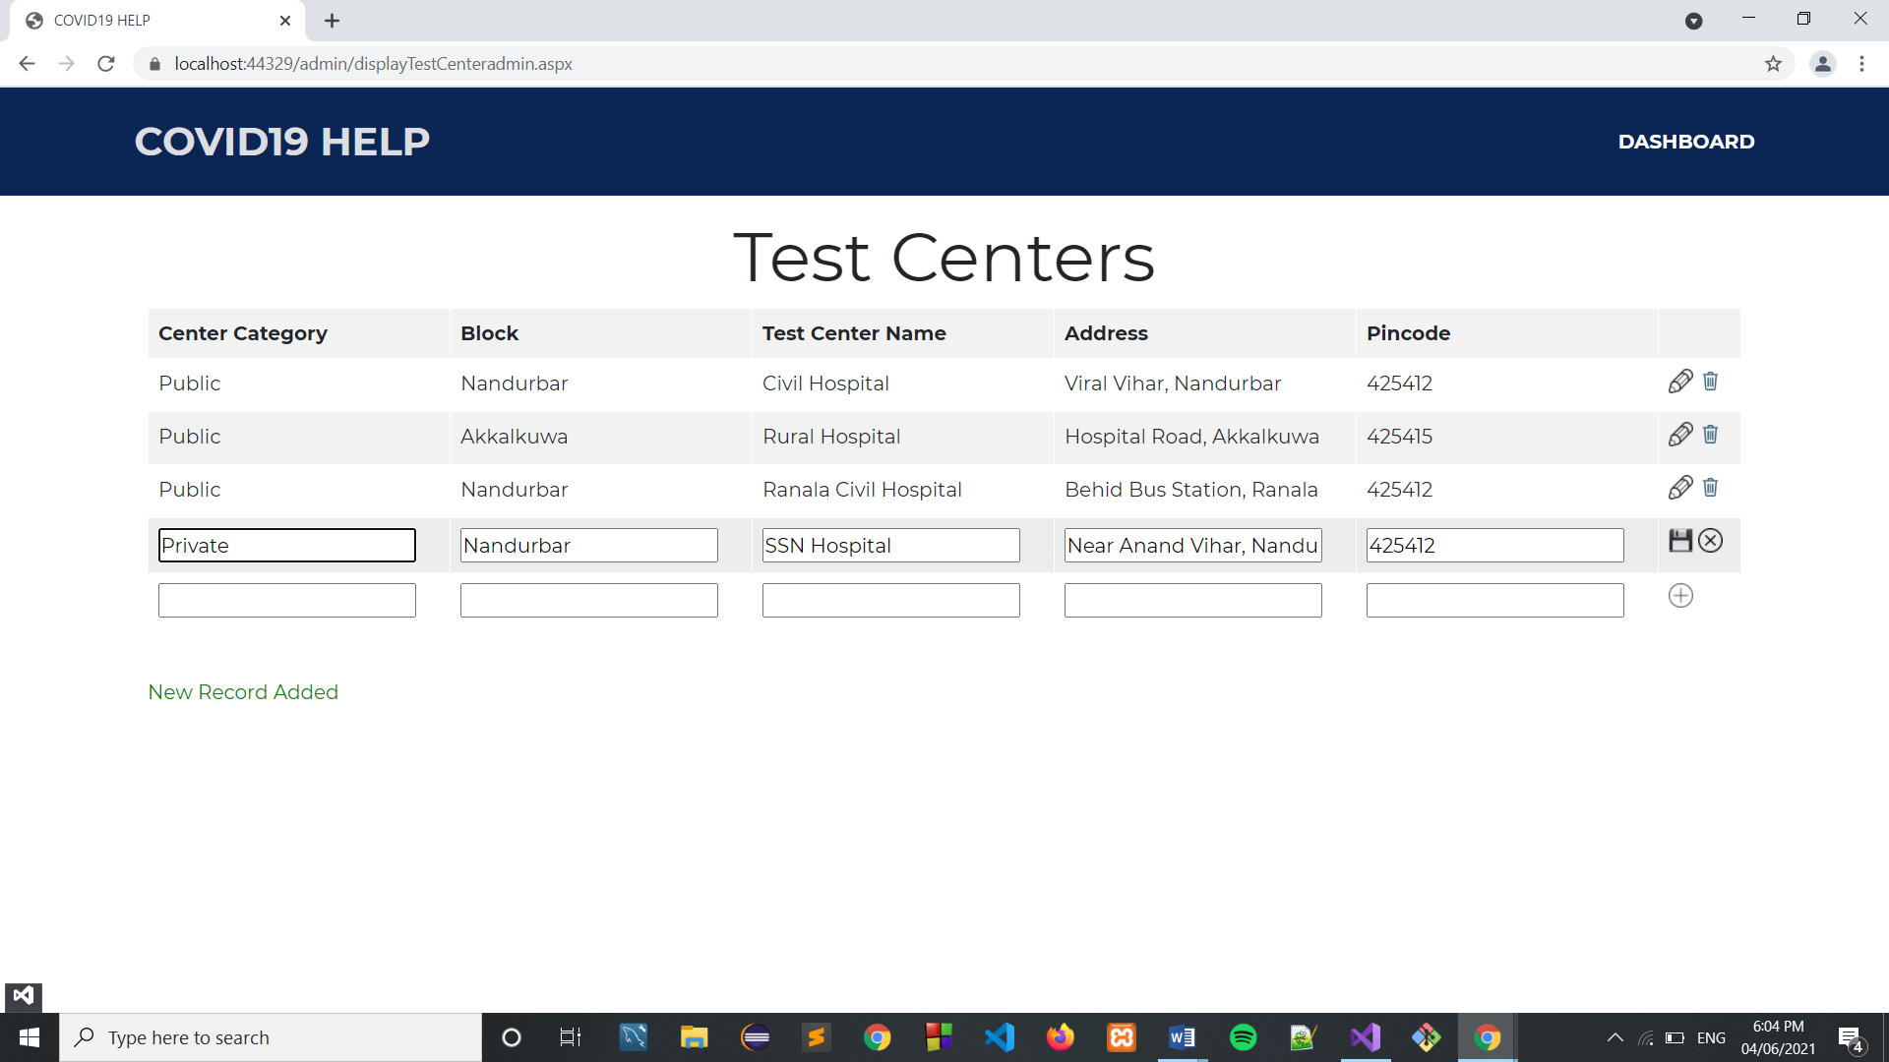

**After Updating ->**

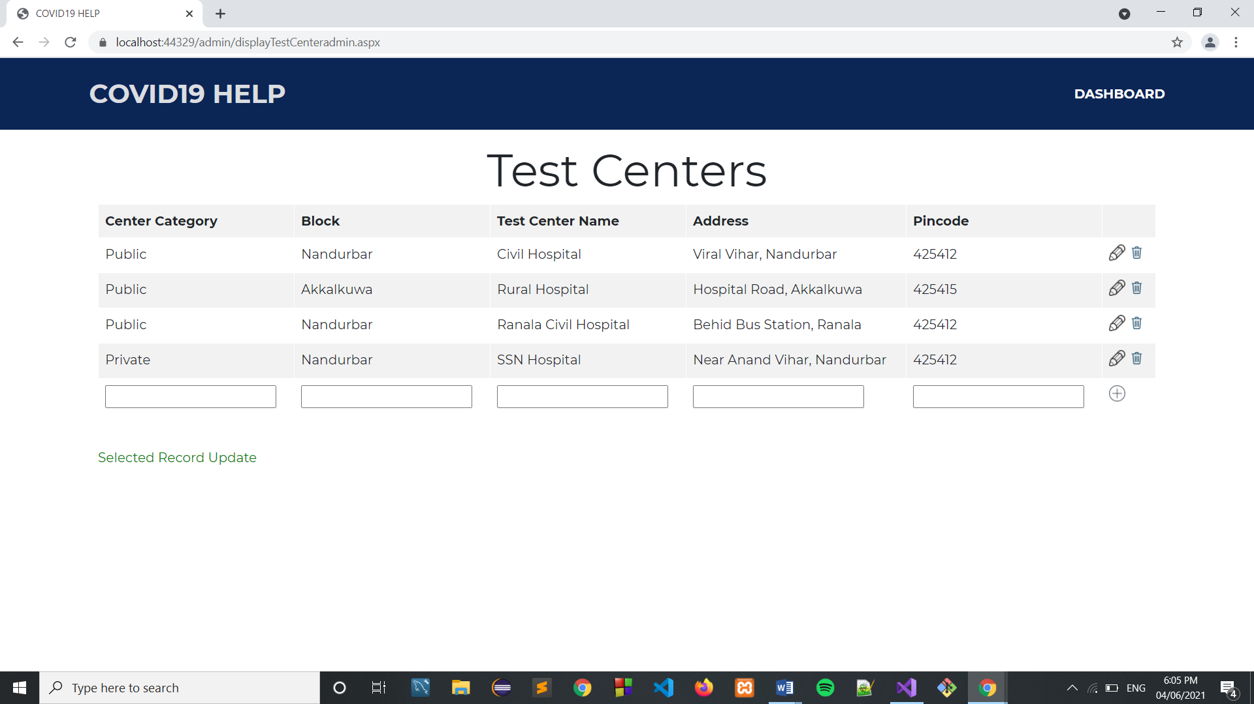

**Deleting Test Center ->**

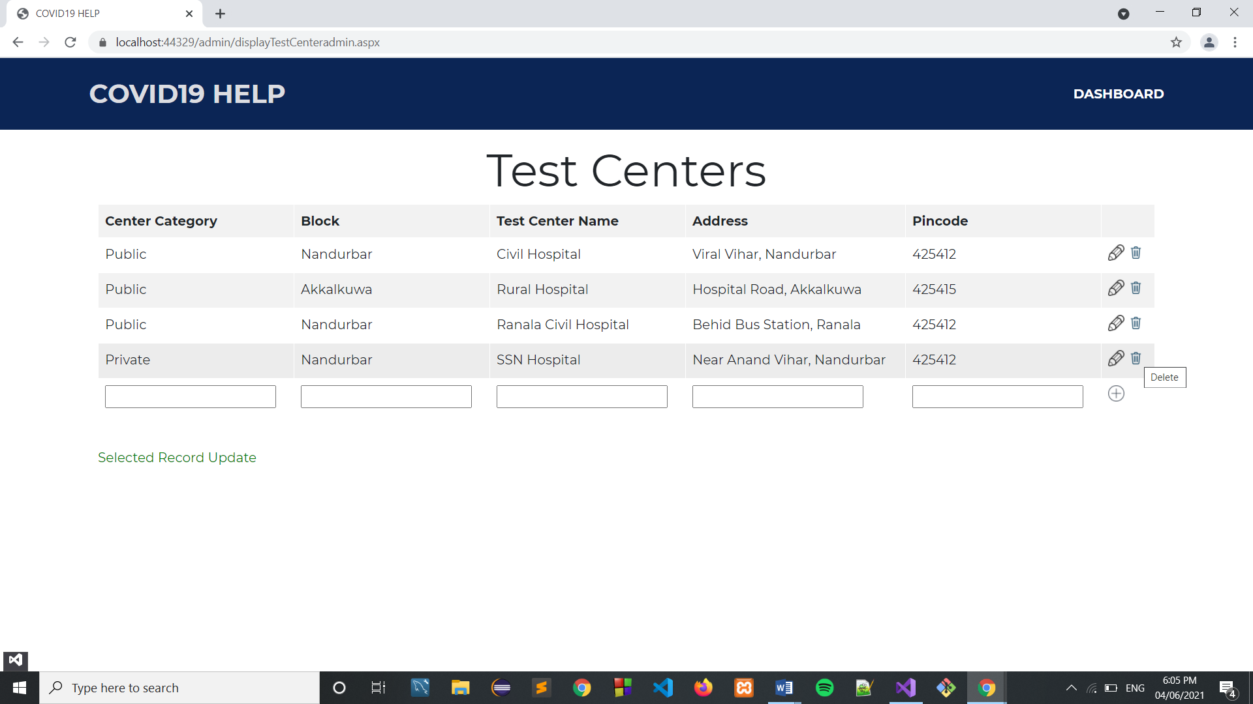

**After Deleting ->**

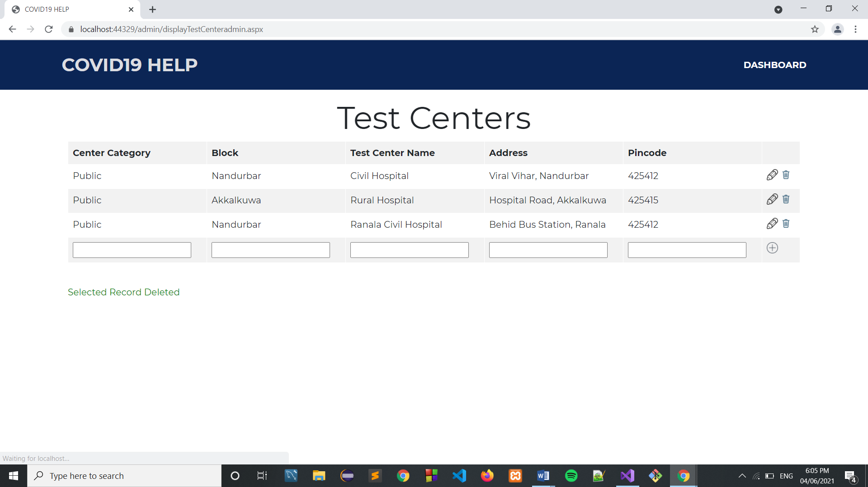

**COVID Dashboard ->**

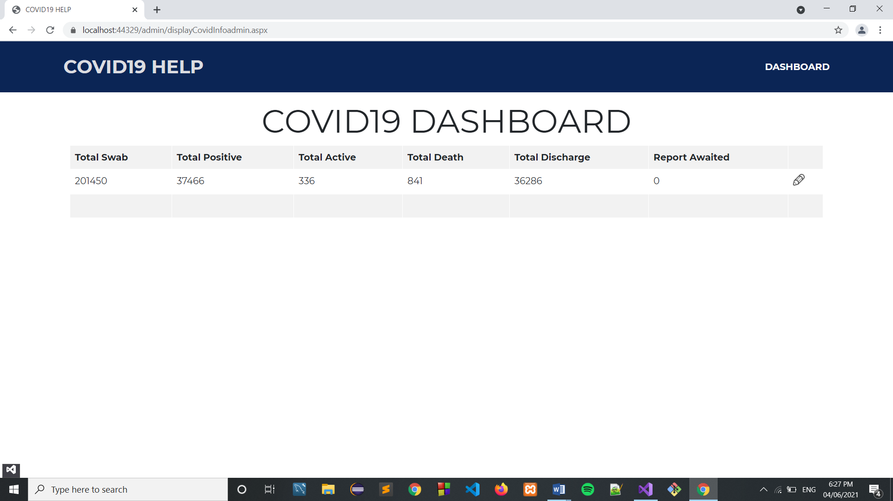

**Updating Cases ->**

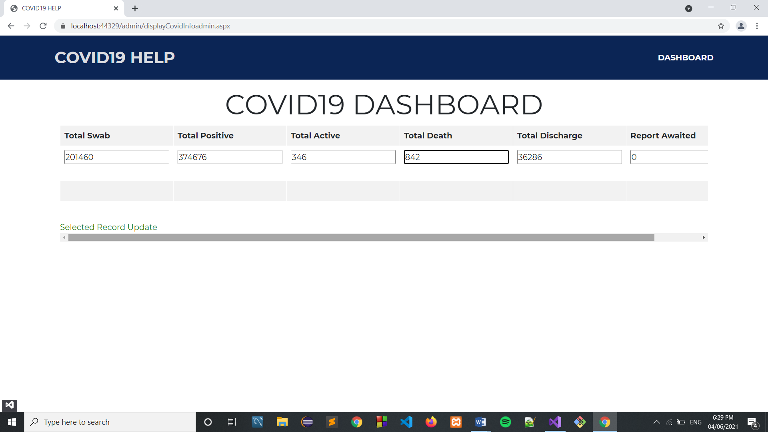

**After Updating cases ->**

